Information I would like about my hospital stay

 | Information about | This is important to me  Tick
 | Information about going to hospital
 | Why I am in hospital and what will happen
 | What happens when I arrive at hospital
 | Treatment to help my mental health

What my days will be like in hospital

Mental health workers who work in this hospital
How the hospital workers should treat me
Support from people I trust
My rights

 | My duties while in hospital
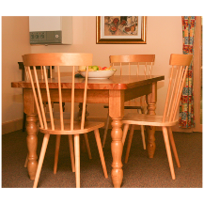 | Daily life in hospital
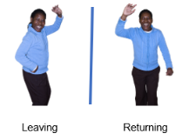 | Leave from hospital
 | Going home at the end of my stay in hospital
 | When I am worried about how I am being treated

Information I would like about my hospital stay

Authors
Janelle Weise¹, Bronwyn Newman¹, Claire Eagleson¹, Karen Fisher², and Julian Trollor¹.

¹Department of Developmental Disability Neuropsychiatry, School of Psychiatry, Faculty of Medicine, UNSW Sydney
²Social Policy Research Centre, Faculty of Arts and Social Sciences, UNSW Sydney

This planning sheet is part of a series of easy read resources explaining
- how people can access public mental health services in New South Wales and
- what they can expect.

For information on how to support people to use easy read see Making mental health information accessible for people with intellectual disability – A Toolkit

© Department of Developmental Disability Neuropsychiatry UNSW Sydney 26.11.20 v1

