Information about going to hospital

 | This easy read information sheet is about getting ready to go to hospital.
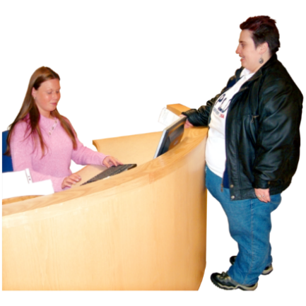 | Going to hospital  You are going to <insert hospital/unit> soon.  This sheet gives you information about what to bring.  It also tells you where to go.  And who to talk to when you have questions.
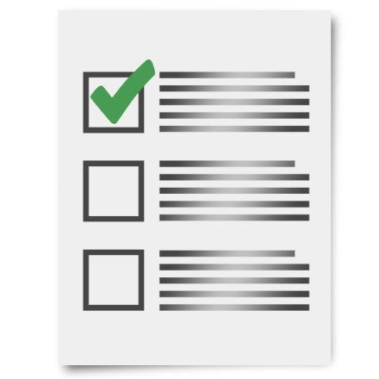  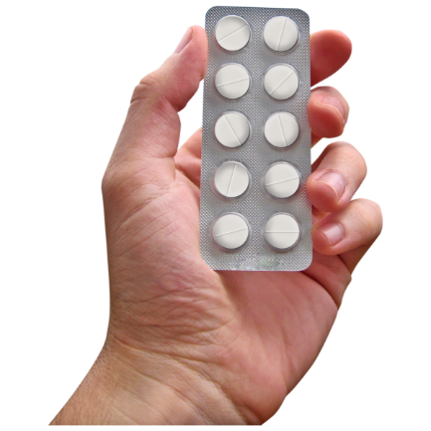 | What to bring to hospital  You should bring to hospital information about  - your medical problems  - health workers you see  - results of medical tests you have had such as blood tests  - medications you take  Medication is sometimes called medicine or drugs.  Medication can be in  - a tablet  - a pill  - a drink  - a needle  Doctors tell people which medicine to take to help make them better.
You can bring your health record if you have one.

This is sometimes called a health folder or health passport.

A health passport is a list of important information about you and your health.

Some people have a health passport to take to different check ups or hospital.
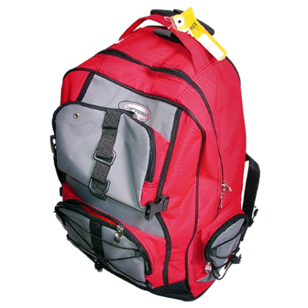 | <Insert list of other items e.g. what clothes/toiletries/personal items to bring>
You can bring a small amount of money with you to hospital

<Suggest $ value> is a good amount.

What you should leave at home

You should not bring lots of money to hospital.

You should not bring valuable items like jewels that cost a lot of money.

Valuable items can get lost in hospital.

<Insert other items that should not be brought to hospital>
Where to come

The <hospital/unit> is at

<insert address in bold>

The <hospital/unit> is marked on the map you have been given.
 | Come to <reception> and let <insert appropriate person> know your name.
Who to talk to when you have questions

If you have questions you can call <insert appropriate person> on <insert phone number in bold>.

If you have questions you can also email <insert appropriate person> at

<insert email address in bold>

You can also ask someone you trust to call us or email us.

This could be
- a family member
- a friend
- a support person

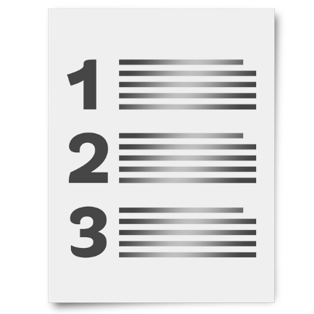 | There is a list of what some words mean in this information sheet here or go to www.3dn.unsw.edu.au/projects/easyread

Information about going to hospital

Authors
Janelle Weise¹, Bronwyn Newman¹, Claire Eagleson¹, Karen Fisher², and Julian Trollor¹.

¹Department of Developmental Disability Neuropsychiatry, School of Psychiatry, Faculty of Medicine, UNSW Sydney
²Social Policy Research Centre, Faculty of Arts and Social Sciences, UNSW Sydney

This information sheet is part of a series of easy read resources explaining
- how people can access public mental health services in New South Wales and
- what they can expect.

For information on how to support people to use easy read see Making mental health information accessible for people with intellectual disability – A Toolkit

© Department of Developmental Disability Neuropsychiatry UNSW Sydney 26.11.20 v1

