My duties while in hospital

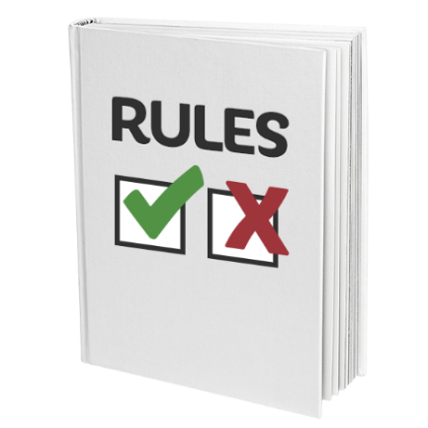 | This easy read information sheet is about your duties while you are in hospital.  Duties means things that you should do and rules you should follow.
Treat other people well

Other people who stay in the hospital may tell you personal things.

Do not repeat what they tell you to other people.
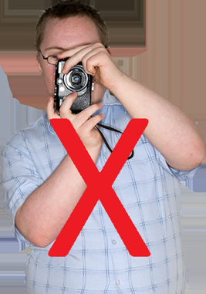 | Do not take photos of other people staying or working in the hospital.
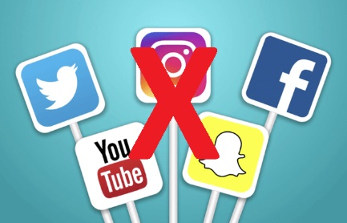 | Do not put information on social media or the internet about people who are staying or working in the hospital.
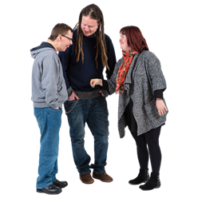 | Getting along with others  Everyone in this hospital should feel comfortable and safe.
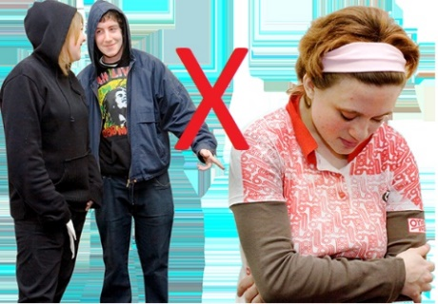 | Do not say hurtful things to other people.
 | Do not physically hurt other people.
 | Do not touch or use other people’s things unless they have said you can.
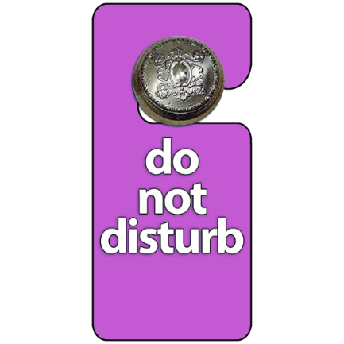 | Give people their personal space.  This means do not go into other people’s bedrooms.
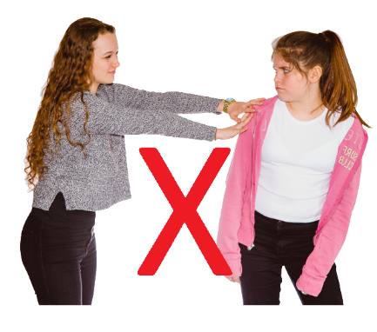 | It also means do not touch other people.  <Insert any other rules e.g. no borrowing etc>
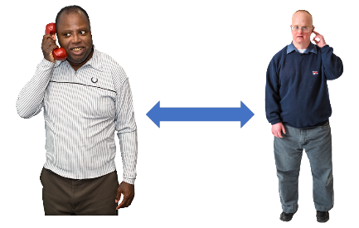 | When someone is on the phone you should not stand too close to them.  You should not listen to what they are saying.
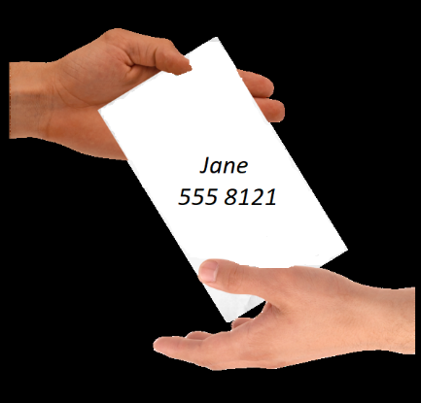 | Personal and sexual safety  Be careful giving your phone number or address to other people.  You can talk to someone you trust about this if you want.
Sexual relationships are <not allowed/not suggested- insert rules> at <hospital/unit>.

You should tell a hospital worker if another person touches you or makes you feel uncomfortable.

You should tell a hospital worker straight away if anyone wants you to take part in sexual activity.

The hospital worker can help you.
Safety

<Insert procedure and who to talk to> if you do not feel safe at any time.
 | You can lock your personal items away in <insert location> so they do not get taken.
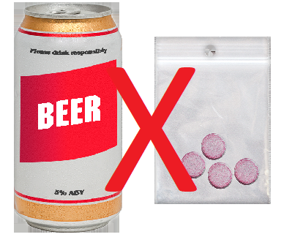 | Drugs and alcohol  You are not allowed to bring drugs or alcohol into <hospital/unit name>.  If you have drugs or alcohol with you <insert measures>.  We will need to tell the police if you have any illegal drugs with you.  Illegal drugs are ones that the law does not allow you to have.
Talk to your <health care team> if you usually use alcohol or drugs.

Your <health care team> will work out a plan with you to help you feel comfortable.
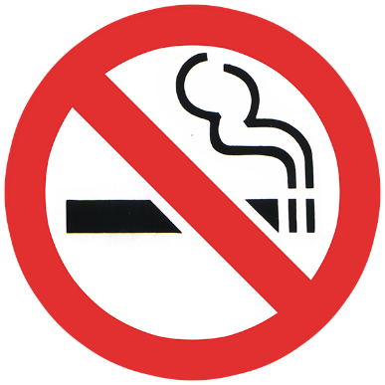 | Smoking  Smoking is not allowed in this hospital.  If you smoke, please talk to <insert appropriate person>.
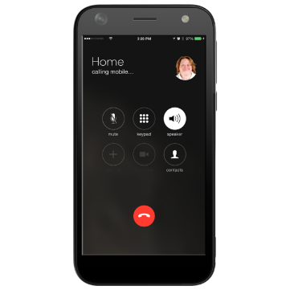 | Mobile phones and cameras  You <can/cannot> bring your mobile phone into this <hospital/unit>.  [If allowed]  You must take care of your phone.
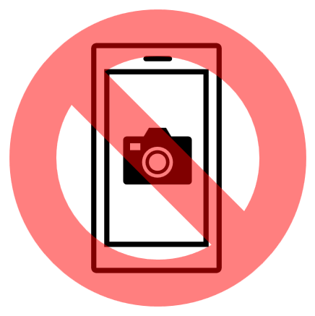 | You cannot use the camera on your phone in this <hospital/unit>.
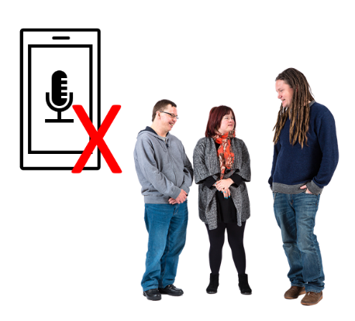 | You cannot use your phone to record conversations.
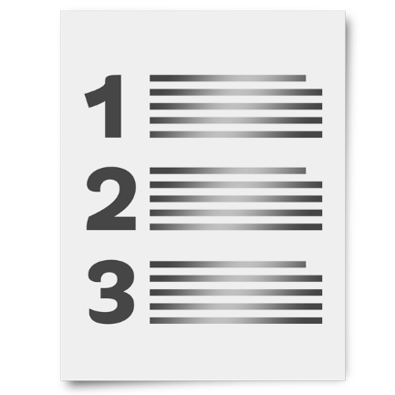 | There is a list of what some words mean in this information sheet here or go to www.3dn.unsw.edu.au/projects/easyread

My duties while in hospital

Authors
Janelle Weise¹, Bronwyn Newman¹, Claire Eagleson¹, Karen Fisher², and Julian Trollor¹.

¹Department of Developmental Disability Neuropsychiatry, School of Psychiatry, Faculty of Medicine, UNSW Sydney
²Social Policy Research Centre, Faculty of Arts and Social Sciences, UNSW Sydney

This information sheet is part of a series of easy read resources explaining
- how people can access public mental health services in New South Wales and
- what they can expect.

For information on how to support people to use easy read see Making mental health information accessible for people with intellectual disability – A Toolkit

© Department of Developmental Disability Neuropsychiatry UNSW Sydney 26.11.20 v1

