Daily life in hospital

This easy read information sheet is about day to day life while you are in hospital.

It will help you know
- what you can have in hospital
- what you can use around the hospital
- what you need to do while in hospital
Personal items you can have in hospital

You can have some of your own things with you while you are in hospital.

You can ask a family member or friend to bring personal items to you.

You can have
<Insert list of items e.g.>
- clothes
- toiletries
- personal items
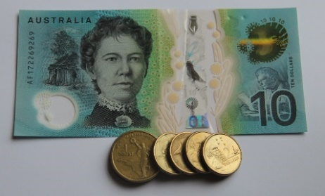 | You can have a small amount of money with you in hospital.  <Suggest $ value> is a good amount to have.  You can buy <insert what, when and where>.
Items you should not have in hospital

You should not have lots of money with you in hospital.
You should not have valuable items with you in hospital.

They can get lost.

Valuable items are things like jewels that costs lots of money.

<Insert other items that should not be brought to hospital>
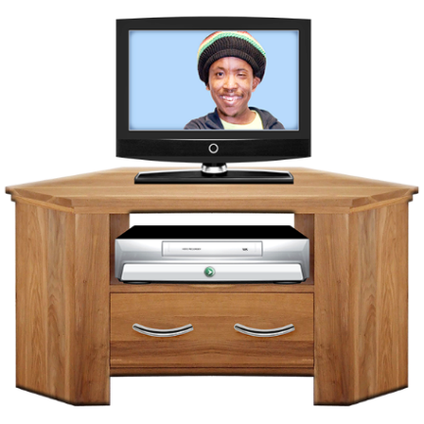 | What you can use around the hospital  <Insert brief details on facilities available e.g.>  You can use the television room.  The television room is in <location>.  You can watch television anytime from <insert times>.
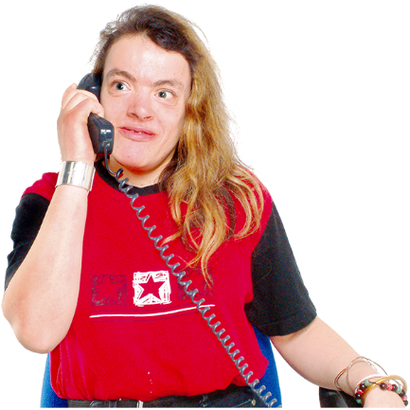 | A phone is in <insert location>.  You can use the phone <insert times>.  You <have to/ do not have to> pay to make calls.  Please keep calls to <insert length> so other people can use the phone.
You can use the kitchen.
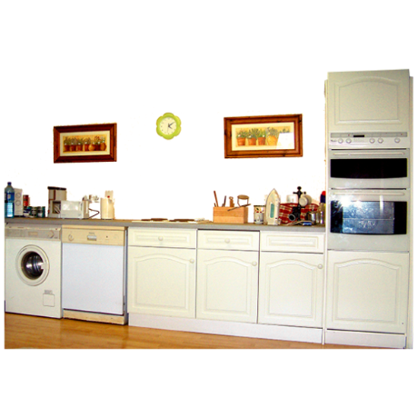
The kitchen is located <insert location>.

You can get a drink or a snack in the kitchen.

You can get a drink or a snack any time from <insert times>.
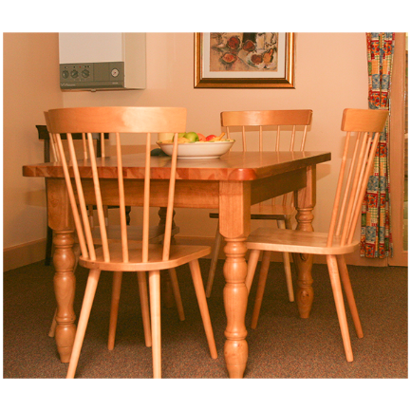 | Meals  You are given meals in hospital.  Meals are served in the dining room.  You will be shown the dining room.  Meal times are  - breakfast <>  - morning tea <>  - lunch <>  - afternoon tea <>  - dinner <>
 | Tell <Insert appropriate person> if there are foods you do not eat.
You should eat any food you have while it is fresh.

Ask <appropriate person> if you have questions about storing your food.
Cleaning <amend as necessary>

Please keep your room tidy.

Hospital cleaners will clean your room.

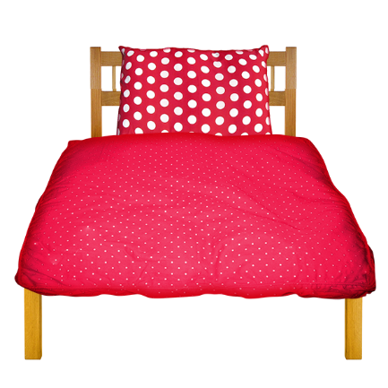 | You should change your sheets, pillowcase and towels once per week.  You can ask <Insert appropriate person> for help to change your sheets, pillowcase and towels.
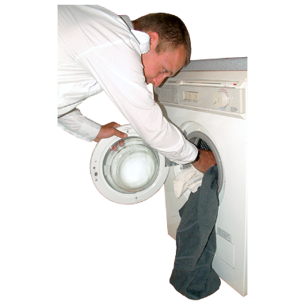 | Laundry <amend as necessary>  You can use the washing machine and dryer to wash your clothes.  You will be shown the laundry room.  You can use the laundry powder.  You will do your own laundry.  Ask <Insert appropriate person> if you need help with your laundry.  My day and time to do my laundry is: Day__________  Time____________

Daily life in hospital

Authors
Janelle Weise¹, Bronwyn Newman¹, Claire Eagleson¹, Karen Fisher², and Julian Trollor¹.

¹Department of Developmental Disability Neuropsychiatry, School of Psychiatry, Faculty of Medicine, UNSW Sydney
²Social Policy Research Centre, Faculty of Arts and Social Sciences, UNSW Sydney

This information sheet is part of a series of easy read resources explaining
- how people can access public mental health services in New South Wales and
- what they can expect.

For information on how to support people to use easy read see Making mental health information accessible for people with intellectual disability – A Toolkit

© Department of Developmental Disability Neuropsychiatry UNSW Sydney 26.11.20 v1

