Leave from hospital

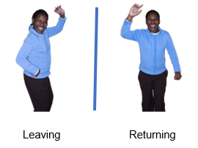 | This easy read information sheet is about leave from hospital.  Leave means that you can go out of the hospital for a while and come back.
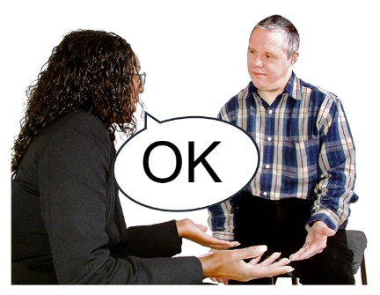 | <Involuntary version>  You are an involuntary patient.  An involuntary patient is someone who must stay in hospital for mental health treatment until they are well enough to go home.  This means you can only leave the hospital if your <health care team> says it is OK.  You may be given leave later in your stay in hospital.  Your <health care team> will talk with you about the type of leave that is best for you.  They may also talk to your family and support people.
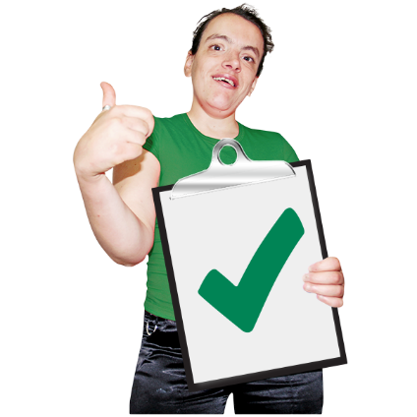 | <Voluntary version>  You are a voluntary patient.  As a voluntary patient you can leave the hospital if you want.
Your <health care team> need to know you are leaving.

You should talk to your <health care team> about options for leave.

Leave should be arranged before your planned outing from the hospital.

You still need to be back in time for appointments with your <health care team>.
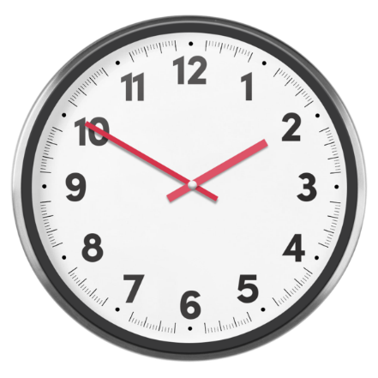 | <All>  If you go on leave it is important that you come back to hospital on time.  If you will be late you need to call <insert appropriate person> on <insert phone number in bold>.
 | There is a list of what some words mean in this information sheet here or go to www.3dn.unsw.edu.au/projects/easyread

Leave from hospital

Authors
Janelle Weise¹, Bronwyn Newman¹, Claire Eagleson¹, Karen Fisher², and Julian Trollor¹.

¹Department of Developmental Disability Neuropsychiatry, School of Psychiatry, Faculty of Medicine, UNSW Sydney
²Social Policy Research Centre, Faculty of Arts and Social Sciences, UNSW Sydney

This information sheet is part of a series of easy read resources explaining
- how people can access public mental health services in New South Wales and
- what they can expect.

For information on how to support people to use easy read see Making mental health information accessible for people with intellectual disability – A Toolkit

© Department of Developmental Disability Neuropsychiatry UNSW Sydney 26.11.20 v1

