Going home at the end of my stay in hospital

 | This easy read information sheet is about what will happen when you go home at the end of your stay in hospital.
Going home

Your <health care team> want to make sure you have recovered enough to go home.

Recovered means getting better so you can do the things you want to do.
Your <health care team> will talk with you about going home from hospital.

You can ask <Insert appropriate person> about going home.

To leave hospital is also called discharge.
Your plan to go home

Your <health care team> will help you make a plan to leave hospital.
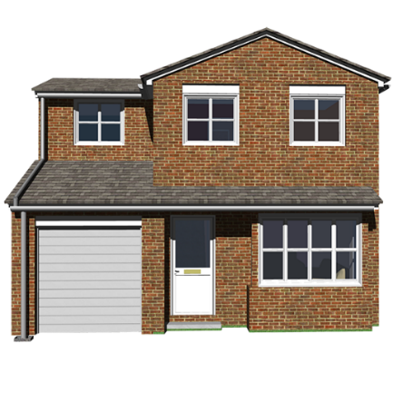 | Help you will have when you go home  Your <health care team> will talk with you about help you will get when you are at home.  You can ask your <health care team> questions about what happens when you go home.
Your discharge plan will list the treatment and support you will get when you go home.

Treatments are things that can help you to feel better.
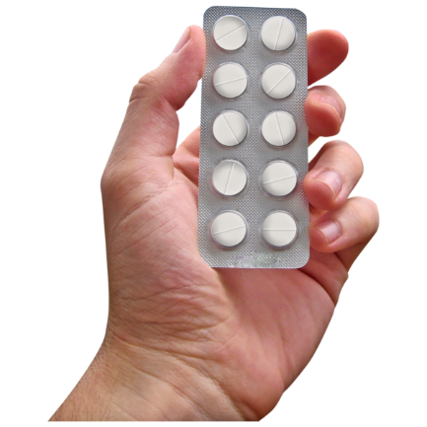 | Doctors tell people which medication to take to help make them better.  Medication is sometimes called medicine or drugs.  Medication can be in  - a tablet  - a pill  - a drink  - a needle  If you take medication we will give you <medication to take home/a prescription for further medication>.
Your <Insert appropriate person> will keep in contact with you when you are at home.

<Insert appropriate person> might
- call you on the phone
- email you
- visit you at home

You can ask <Insert appropriate person> questions and they will give you help.
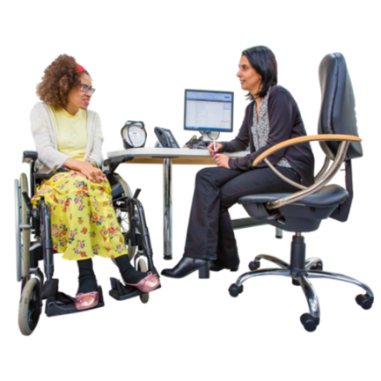 | We will send your discharge plan to your general practitioner.  Your general practitioner is your regular doctor.  They are also called your GP.  You should keep seeing your GP regularly.
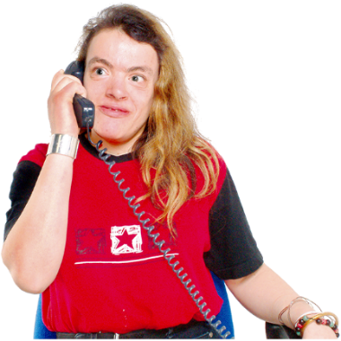 | We will give you a list of phone numbers you can call when you have questions or need help.
 | There is a list of what some words mean in this information sheet here or go to www.3dn.unsw.edu.au/projects/easyread

Going home at the end of my stay in hospital

Authors
Janelle Weise¹, Bronwyn Newman¹, Claire Eagleson¹, Karen Fisher², and Julian Trollor¹.

¹Department of Developmental Disability Neuropsychiatry, School of Psychiatry, Faculty of Medicine, UNSW Sydney
²Social Policy Research Centre, Faculty of Arts and Social Sciences, UNSW Sydney

This information sheet is part of a series of easy read resources explaining
- how people can access public mental health services in New South Wales and
- what they can expect.

For information on how to support people to use easy read see Making mental health information accessible for people with intellectual disability – A Toolkit

© Department of Developmental Disability Neuropsychiatry UNSW Sydney 26.11.20 v1

