When I am worried about how I am being treated

This easy read information sheet will help you if you are worried about how you are being treated in hospital.

It will tell you
- who you can talk to
- how to make a complaint if you are not happy
Who you can talk to in hospital

You can talk to <Insert appropriate person>.

You can <insert details how they can talk to them>.
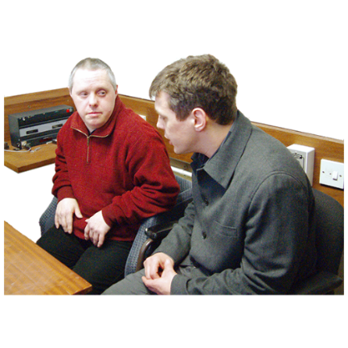 | You can talk to <Insert appropriate person at hospital> if you are not happy with what <Insert appropriate person> says and does.  You can talk to <Insert appropriate person> by <insert details>.
If you do not want to talk to hospital workers that is OK too.

You can talk to other people.

You can also talk to
- your family
- your friend
- your support person

Official Visitors

Official Visitors are people who visit the hospital.

Official Visitors make sure people in hospital are treated well.

Official Visitors do not work for the hospital.

You can tell an Official Visitor your ideas on how the hospital can treat you better.

You can make a complaint with the Official Visitor.
 | A complaint is when you tell someone you are not happy with something.
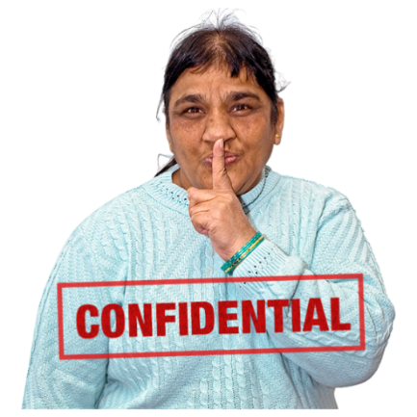 | All complaints are confidential.  Confidential means information about you that people should not share with others.  This means only people who are dealing with the complaint will know about it.
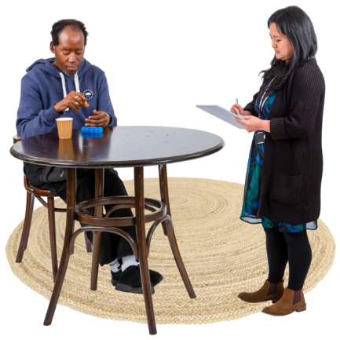 | You can talk to an Official Visitor when they visit your hospital.  You do not have to talk to an Official Visitor if you do not want to.  You can ask someone you trust to tell the hospital workers you would like to talk to the Official Visitor.  This can be  - a family member  - a friend  - a support person
You can leave a letter in the Official Visitors box.

The Official Visitors box is a locked box on the ward.

<Insert appropriate person> can show you where the Official Visitor box is.

Only Official Visitors can read the letters in this box.
If you want to talk to an Official Visitor you can also call 1800 208 218.

This call does not cost money.
To write to an Official Visitor you can email

OfficialVisitorsProgram@health.nsw.gov.au
For more information about Official Visitors see the website
https://officialvisitorsmh.nsw.gov.au
Other ways you can make a complaint

You can also make a complaint by talking or writing to other people.
You can talk to <Insert appropriate person> when you want to make a complaint.

You can talk to <Insert appropriate person> by <insert details e.g. phone number in bold>.
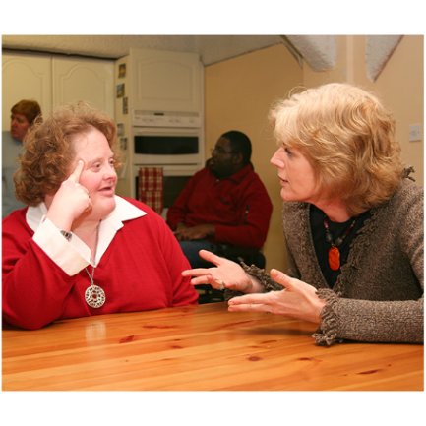 | You can make a complaint to < Insert appropriate person> when you are not happy with what <Insert appropriate person> says and does.  You can talk to <appropriate person> by  <insert details e.g. phone number in bold>.
If you do not want to make a complaint to hospital workers that is OK too.

You can make a complaint to other people.

You can contact the Health Care Complaints Commission when you do not want to talk to hospital workers.

You can also contact the Health Care Complaints Commission when you are not happy with what <Insert appropriate person> says and does.
 | You need to make complaints to the Health Care Complaints Commission in writing.
You can ask someone you trust to help you write the complaint.

You can ask
- a family member
- a friend
- a support person

The Health Care Complaints Commission can also help you write your complaint.

You can call them on 1800 043 159.

This call does not cost money.
 | You can fill in a form at this website https://ecomplaints.hccc.nsw.gov.au/.
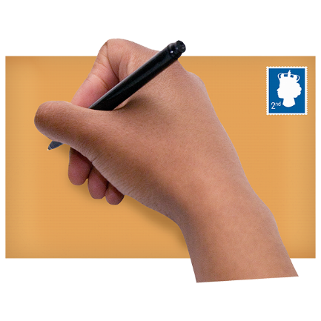 | You can also send the complaint in writing to  Health Care Complaints Commission  Locked Mail Bag 18  STRAWBERRY HILLS NSW 2012
Or by email to

hccc@hccc.nsw.gov.au

For more information you can visit the Health Care Complaints Commission website at

www.hccc.nsw.gov.au
You can ask someone you trust to make a complaint for you.

This could be
- a family member
- a friend
- a support person
- a hospital worker
 | There is a list of what some words mean in this information sheet here or go to www.3dn.unsw.edu.au/projects/easyread

When I am worried about how I am being treated

Authors
Janelle Weise¹, Bronwyn Newman¹, Claire Eagleson¹, Karen Fisher², and Julian Trollor¹.

¹Department of Developmental Disability Neuropsychiatry, School of Psychiatry, Faculty of Medicine, UNSW Sydney
²Social Policy Research Centre, Faculty of Arts and Social Sciences, UNSW Sydney

This information sheet is part of a series of easy read resources explaining
- how people can access public mental health services in New South Wales and
- what they can expect.

For information on how to support people to use easy read see Making mental health information accessible for people with intellectual disability – A Toolkit

© Department of Developmental Disability Neuropsychiatry UNSW Sydney 26.11.20 v1

