Why I am in hospital and what will happen

This easy read information sheet is about why you are in hospital.

This information sheet is also about what will happen while you are in hospital.

<Use picture of actual hospital/unit  if possible> | Where you are  You are in the <insert name of hospital/unit>.  The <hospital/unit> is in <insert suburb>.
Why you are in hospital

You are here so you can get help with your mental health.

Mental health is about how you think and how you feel.
 | A mental health problem is when feelings start to bother you.
When you have a mental health problem it can change
- how you think
- how you feel
- what you do

For example you can
- have worried thoughts
- feel very sad
- not feel like doing things you enjoy

If you have a mental health problem
it can be hard to cope.
You can ask <insert appropriate person> when you are not sure why you have come to hospital.

<Insert appropriate person> can tell you why you are in hospital.

How long you will stay in hospital

It can be hard to tell how long you need to stay in hospital.

We will keep your stay in hospital as short as possible.

You will stay in hospital until you are well enough to go home.

<Insert appropriate person> will talk to you about how long you will stay in hospital.
<Involuntary version>

Going home

You are an involuntary patient

An involuntary patient is someone who must stay in hospital for mental health treatment until they are well enough to go home.
It is not your choice when you can leave.

You can go home when your doctor says you can.

But you can tell your doctor that you want to go home at any time.

You can get someone you trust to help you to ask or ask for you.

Your doctor will decide if you are well enough to go home.
<Voluntary version>

Going home

You are a voluntary patient.

You are a voluntary patient if you choose to go to hospital for mental health treatment.

You have the choice to leave hospital if you want.
 | Talk to <insert appropriate person> if you want to go home.
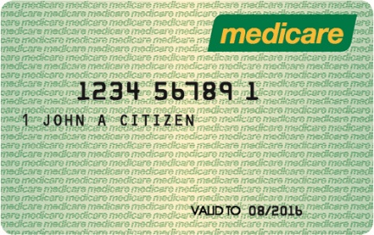 | Money for this hospital stay  If you have a medicare card, you do not have to pay money for this hospital stay.
If you do not have a medicare card
talk to <insert appropriate person> about money you may have to pay.

 | Talk to <insert appropriate person> when you have any questions about why you are in hospital and what is happening.
 | There is a list of what some words mean in this information sheet here or go to www.3dn.unsw.edu.au/projects/easyread

Why I am in hospital and what will happen

Authors
Janelle Weise¹, Bronwyn Newman¹, Claire Eagleson¹, Karen Fisher², and Julian Trollor¹.

¹Department of Developmental Disability Neuropsychiatry, School of Psychiatry, Faculty of Medicine, UNSW Sydney
²Social Policy Research Centre, Faculty of Arts and Social Sciences, UNSW Sydney

This information sheet is part of a series of easy read resources explaining
- how people can access public mental health services in New South Wales and
- what they can expect.

For information on how to support people to use easy read see Making mental health information accessible for people with intellectual disability – A Toolkit

© Department of Developmental Disability Neuropsychiatry UNSW Sydney 26.11.20 v1

