What happens when I arrive at hospital

This easy read information sheet is about what happens first when you arrive at hospital.

<Modify to reflect order of events and add any additional admission procedures>
What happens when I arrive

When you arrive at the hospital <insert appropriate person> will show you
- your room
- the bathroom
- where you eat meals
- the activities room
- where you see your <health care team>
<Insert other applicable places>

[If available] <Insert appropriate person> will give you a map of the <unit/ward>.
 | You will have a name tag on your wrist.
 | You may talk to a doctor soon after you arrive.
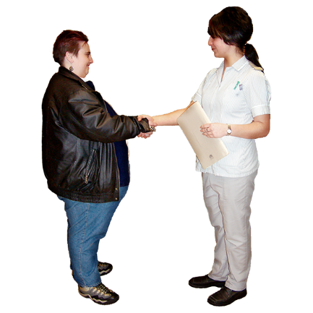 | <Insert appropriate person> will introduce you to people who work at the hospital.  You will meet the people who will care for you while you are in hospital.
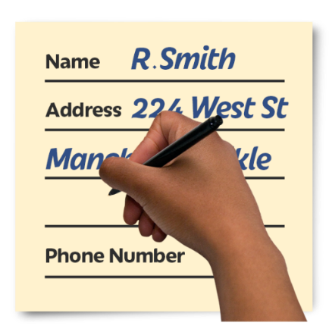 | Filling out forms [If applicable]  You will be asked to fill out these forms  - <Insert appropriate forms>  You will fill out these forms so we know more about you and your health.  Knowing this information will help us to take care of you.
You can ask for more time to fill out these forms.

You can ask someone to help you fill out these forms.
Talk to <Insert appropriate person> if you do not have the information you need to fill out these forms.

<Insert appropriate person> can help you get the information.
Care level

When you arrive at hospital
the mental health workers will talk to you to decide how much care you need.

Mental health workers are people who work to help you with your mental health.
You will be given a care level.

Your care level lets <nurses> know how often they should see you to make sure you are OK.

How often <nurses> see how you are going may change throughout your stay.
 | There is a list of what some words mean in this information sheet here or go to www.3dn.unsw.edu.au/projects/easyread

What happens when I arrive at hospital

Authors
Janelle Weise¹, Bronwyn Newman¹, Claire Eagleson¹, Karen Fisher², and Julian Trollor¹.

¹Department of Developmental Disability Neuropsychiatry, School of Psychiatry, Faculty of Medicine, UNSW Sydney
²Social Policy Research Centre, Faculty of Arts and Social Sciences, UNSW Sydney

This information sheet is part of a series of easy read resources explaining
- how people can access public mental health services in New South Wales and
- what they can expect.

For information on how to support people to use easy read see Making mental health information accessible for people with intellectual disability – A Toolkit

© Department of Developmental Disability Neuropsychiatry UNSW Sydney 26.11.20 v1

