Treatment to help my mental health

This easy read information sheet is about treatments for your mental health.

Treatments are things that can help you feel better.
 | Mental health is about how you think and feel.
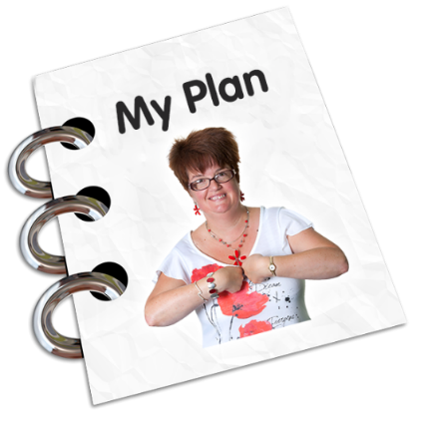 | Treatment plans  A treatment plan is a list of things you can do to help you get better.  A treatment plan is sometimes called a care plan.
Making a treatment plan

You will meet with your <health care team> to talk about your goals for your recovery.

Recovery means getting better so you can do the things you want to do.

Your family and support person may also be at this meeting when that helps you.
You will talk about options for your treatment at this meeting.

You will decide on a treatment plan.

You can tell your <health care team> about your past and current treatments.

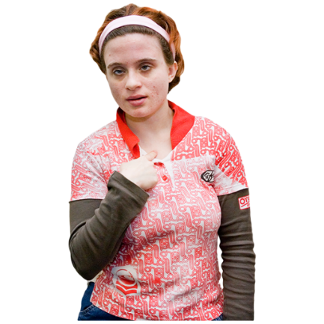 | <Voluntary version>  You can tell your <health care team> what type of treatment you want.  Your <health care team> cannot give you a treatment if you do not want it.
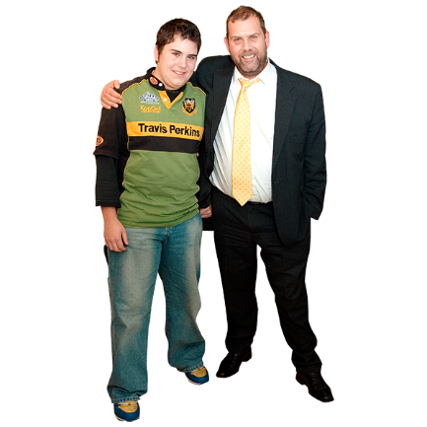 | Some people have a guardian.  A guardian is a person who helps you make decisions about parts of your life when you cannot make decisions by yourself.  If you cannot choose what treatment to have your guardian can decide what treatment would be best for you.
<Involuntary version>
You can tell your <health care team> what type of treatment you would like.

Your <health care team> will try to give you the type of treatment that you want.
You can be given treatment even if you do not want it.

This is because your doctors think it is the best treatment to help you get well.

You must be told what your treatment is.
Treatments this hospital offers

<Insert simple information about treatments offered e.g.>

Talking therapy

Talking therapy is when you talk with a mental health worker to learn ways to cope with how you think or feel.
Mental health workers are people who work to help you with your mental health.

Talking therapy can help you cope with hard problems or worrying thoughts.
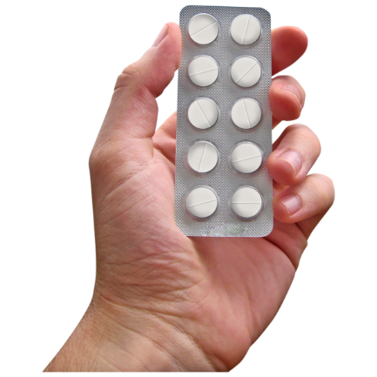 | Medication  Medication is sometimes called medicine or drugs.  Medication can be in  - a tablet  - a pill  - a drink  - a needle  Doctors tell people which medicine to take to make them better.  Medication is a type of treatment.
Your doctor may give you new medication to take.

If you already take medication
your doctor may change the amount you take.
Your doctor may also tell you to stop taking some medications.

We can give you a sheet with this information written down.

You can write down the changes on your
own medication chart if you have one.
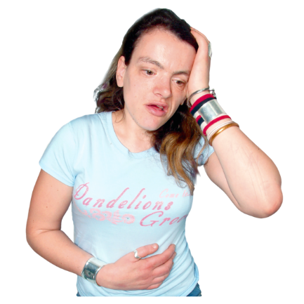 | Some medication can give you side effects.  A side effect can make you feel unwell.  Your doctor will tell you how the medication may make you feel.  We can give you a sheet with this information written down.
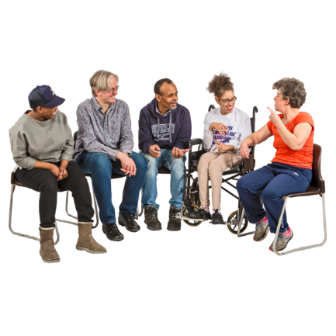 | Support groups  A support group is a small group of people you meet with to talk about mental health.  People usually talk about how they feel and things that make them feel better.
[As applicable]
This hospital has support groups.

You <do/do not> have to attend support groups.

<Insert appropriate person> will tell you when the support groups meet.
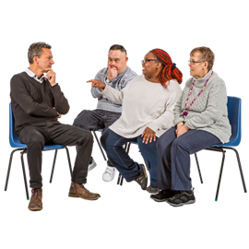 | Other support groups are outside this hospital.  You will be given information on support groups you can go to when you go home.
 | There is a list of what some words mean in this information sheet here or go to www.3dn.unsw.edu.au/projects/easyread

Treatment to help my mental health

Authors
Janelle Weise¹, Bronwyn Newman¹, Claire Eagleson¹, Karen Fisher², and Julian Trollor¹.

¹Department of Developmental Disability Neuropsychiatry, School of Psychiatry, Faculty of Medicine, UNSW Sydney
²Social Policy Research Centre, Faculty of Arts and Social Sciences, UNSW Sydney

This information sheet is part of a series of easy read resources explaining
- how people can access public mental health services in New South Wales and
- what they can expect.

For information on how to support people to use easy read see Making mental health information accessible for people with intellectual disability – A Toolkit

© Department of Developmental Disability Neuropsychiatry UNSW Sydney 26.11.20 v1

