What my days will be like in hospital

 | This easy read information sheet is about what you will do each day in hospital.
Meetings

You will talk with people in your <health care team>.

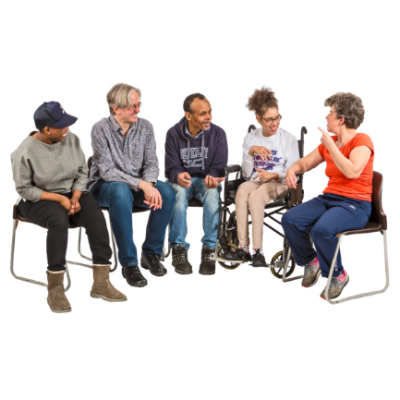 | You <can/will> also go to support groups.  A support group is a small group of people you meet with to talk about mental health.  People usually talk about how they feel and things that make them feel better.  Support groups you can go to include <list>
Activities

There are different activities that you can do each <day/weekday>.

These activities will help you learn skills and feel better.

Activities you can do include
- <Insert simple list>

You must take part in <all/percentage of meetings and activities>.
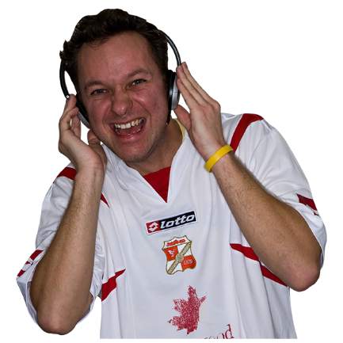 | Relaxing  You have free time each day.  Things you can do during free time include  - <Insert simple list of activities>
Sleep

A good night of sleep is important to help you feel good.

It is best if you go to sleep at the same time each night.

You can tell your <health care team> when you have trouble sleeping.

Your <health care team> can help you with ways to sleep better.
Exercise

Exercise is important to help you feel good.

This <hospital/unit> has an exercise program.

It is good for you to join the exercise program.
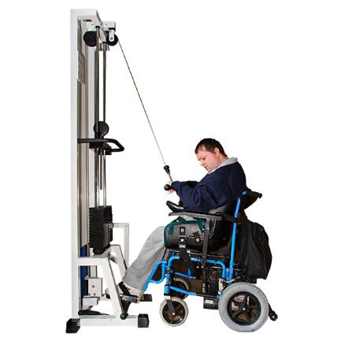 | [If applicable] You can use the hospital gym.  Ask <appropriate person> how to use the gym.
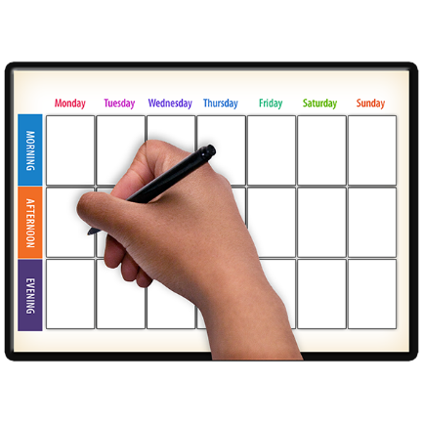 | We can write down your activities and meetings for each day.
 | There is a list of what some words mean in this information sheet here or go to www.3dn.unsw.edu.au/projects/easyread

What my days will be like in hospital

Authors
Janelle Weise¹, Bronwyn Newman¹, Claire Eagleson¹, Karen Fisher², and Julian Trollor¹.

¹Department of Developmental Disability Neuropsychiatry, School of Psychiatry, Faculty of Medicine, UNSW Sydney
²Social Policy Research Centre, Faculty of Arts and Social Sciences, UNSW Sydney

This information sheet is part of a series of easy read resources explaining
- how people can access public mental health services in New South Wales and
- what they can expect.

For information on how to support people to use easy read see Making mental health information accessible for people with intellectual disability – A Toolkit

© Department of Developmental Disability Neuropsychiatry UNSW Sydney 26.11.20 v1

