Mental health workers who work in this hospital

 | This easy read information sheet is about the mental health workers who work in this hospital.
Mental health workers are people who work to help you with your mental health.

Mental health is about how you think and how you feel.

<Insert brief descriptions of applicable mental health workers e.g.>

Psychiatrists

A psychiatrist is a doctor who helps you with your mental health.

A psychiatrist will be in charge of your care.
Psychiatrists can prescribe medicine.

To prescribe means to recommend and say it is OK for you to take some kind of medicine.

Psychiatrists can tell you which medicine to take to make your mental health better.
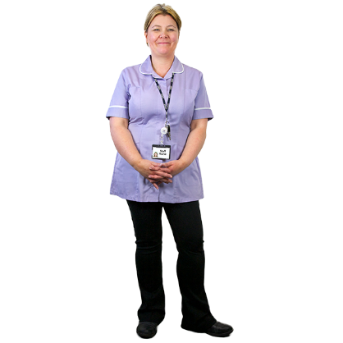 | Mental health nurses  Mental health nurses are the main people who will look after you each day in hospital.  A mental health nurse may give you medicine.  A mental health nurse can also help you with things like having a shower and getting dressed.
Psychologists

A psychologist helps you with your mental health by talking with you.

Psychologists help you find things you can do to feel better.

Psychologists do not give you medication.
Social workers

A social worker is a mental health worker who helps you find the support you need to stay well.

You can talk to a social worker when you need information about services or support for you or your family.
Occupational therapist

Occupational therapists help people take part in daily activities and support them to learn new skills.
Case managers

A case manager is a health worker who helps plan and organise your care and other services you will get.
Peer workers

A peer worker is someone who has a lived experience of mental health problems.

A peer worker can support you and help advocate for you.

Dieticians

A dietician helps you to choose the best foods to eat so you can be healthy.
Exercise physiologist

An exercise physiologist suggests exercises you can do to get healthy.

These exercises can help with any illnesses or injuries you may have.
Details of your <health care team>

Your <health care team> has mental health workers who will care for you and provide your treatments.

Treatments are things that can help you feel better.
We will write down the names of your <health care team> on a sheet.

We will also write down when you will meet with people in your <health care team> on this sheet.
 | There is a list of what some words mean in this information sheet here or go to www.3dn.unsw.edu.au/projects/easyread

Mental health workers who work in this hospital

Authors
Janelle Weise¹, Bronwyn Newman¹, Claire Eagleson¹, Karen Fisher², and Julian Trollor¹.

¹Department of Developmental Disability Neuropsychiatry, School of Psychiatry, Faculty of Medicine, UNSW Sydney
²Social Policy Research Centre, Faculty of Arts and Social Sciences, UNSW Sydney

This information sheet is part of a series of easy read resources explaining
- how people can access public mental health services in New South Wales and
- what they can expect.

For information on how to support people to use easy read see Making mental health information accessible for people with intellectual disability – A Toolkit

© Department of Developmental Disability Neuropsychiatry UNSW Sydney 26.11.20 v1

