Title
Introduction to Inpatient Mental Health Services

Authors

Janelle Weise¹, Bronwyn Newman¹, Claire Eagleson¹, Karen Fisher², and Julian Trollor¹.

¹Department of Developmental Disability Neuropsychiatry, School of Psychiatry, Faculty of Medicine, UNSW Sydney

²Social Policy Research Centre, Faculty of Arts and Social Sciences, UNSW Sydney

Description of resource

These information sheets are part of a series of easy read resources explaining how people can access public mental health services in New South Wales and what they can expect.
The Introduction to Inpatient Mental Health Services resource is a series of easy read information sheets designed to provide information to individuals receiving inpatient mental health services. It is provided as a template for mental health services to use.

See the accompanying document Making mental health information accessible for people with intellectual disability – A Toolkit for information on how to support people to use these easy read information sheets.

Please note these are templates and are not ready to be provided to patients as is.

© Department of Developmental Disability Neuropsychiatry UNSW Sydney 26.11.20 v1

Introduction

Easy read is used by people who need support reading and understanding standard written information. This can include people with intellectual disability and other cognitive or communication disorders.

This is a template for developing easy read inpatient mental health service information. This template allows you to develop an easy read resource that is responsive to the needs of your service.

The content in this template was guided by consultation with people with intellectual disability and their families and support persons. The template design has also been co-designed with people with intellectual disability.

How to use this template

Use this template to create easy read resources for your inpatient service.

This template has been developed in sections. It is preferable that the sections are provided as separate information sheets at appropriate times to minimise cognitive load and aid comprehension. However, the sections could be provided to some patients all at once as a booklet with sections highlighting specific topics.

Information that is common to many services is included in the template. This information can be modified and built upon to meet the needs of your service (for example, adding in terms used in your particular service for wording in angled brackets e.g. <health care team>).

Images used in this template are from www.photosymbols.com.

These are templates and are not ready to be provided to patients as is.

General guidelines for creating easy read documents

Some general guidelines for writing easy read documents are below. More information can be found at Scope. The Council for Intellectual Disability (CID) offer easy read training and support in the development and testing of easy read resources.

Design
- Place images to the left of writing.
- Left align text.
- Align main headings to the left of the page.
- Use a wide margin.
- Use a sans serif font such as Arial.
- Size 16 font for body text, 18 or larger for headings.
- Use page numbers (same size font as body text).
- 1.5 or double spacing between lines.
- Start each sentence on a new line.
- Include sufficient white space.
- Try to keep all text about one concept on the same page.
- Start a new page for a new topic.
- Include 3-5 images per page.
- Keep the design and layout the same on each page.

Language
- Include only one idea per sentence.
- Use short sentences (maximum approximately 20 words).
- Use bullet points to list multiple concepts rather than writing them in a sentence.
- Use clear, commonly understood language.
- Use active sentences rather than passive.
- Refer to the reader as ‘you’.
- Use ‘I’ or ‘we’ for the person/organisation writing the document.
- Use nouns/proper nouns rather than pronouns (e.g. your ‘doctor’ or their name, rather than ‘they’).
- Keep terminology consistent throughout the document.
- Avoid acronyms (write out in full in the first instance if used, except if more commonly used e.g. NSW versus New South Wales).
- Avoid jargon or slang.
- Do not write in upper case (except capitalising words).
- Do not use contractions e.g. use cannot rather than can’t.
- When writing numbers, use numerals e.g. 1 rather than one.
- Do not underline words or use italics.
- Bold important words or those that you define.
- Bold phone numbers and web addresses.
- Use minimal punctuation e.g. avoid brackets and colons.

Testing
- It is important to design the resources with people who will be the target audience (co-design). Include people with intellectual disability, their families and support persons, and mental health professionals in testing what you have developed.

Conditions of use

No specific permissions are required to make minor modifications to the resources. Minor modifications may include:
- Changing/adding information in brackets so it is applicable to your service.
- Adding information that is applicable to your service using easy read guidelines.
- Deleting certain information that is not applicable to your service.

For major modifications, please check with Dr Janelle Weise at j.weise@unsw.edu.au. Major modifications may include:
- Deleting large sections of the resources.
- Significantly changing definitions.
- Significantly changing the language used in the resources.

It is the responsibility of each service to seek local approvals for modifications made to the resources. 3DN, UNSW Sydney takes no responsibility for content that has been modified.
The authorship page (16 point font version at the end of the document) should be retained with the booklet/each information sheet if provided separately (with the corresponding section heading as the title). As this page is not in easy read, it must be placed at the end of the document so it does not act a barrier to reading the information sheet.

Branding
- LHD and mental health service logos can be added to the resources.
- NSW Government logo and 3DN, UNSW Sydney logos must remain.

Introduction to inpatient mental health services

Easy read information sheets

List of information sheets

Information about going to hospital
Why I am in hospital and what will happen
What happens when I arrive at hospital
Treatment to help my mental health
What my days will be like in hospital
Mental health workers who work in this hospital
How the hospital workers should treat me
Support from people I trust
My rights
My duties while in hospital
Daily life in hospital
Leave from hospital
Going home at the end of my stay in hospital
When I am worried about how I am being treated

List of planning sheets

Information I would like about my hospital stay
My Medications
Daily Planner
Activities I could do in my free time
My health care team
Information about going to hospital

 | This easy read information sheet is about getting ready to go to hospital.
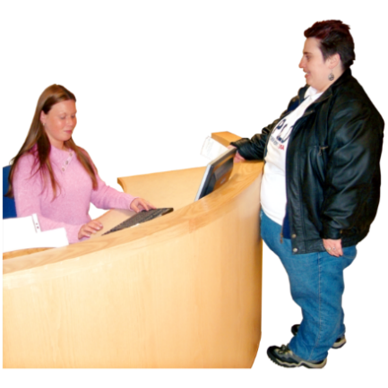 | Going to hospital  You are going to <insert hospital/unit> soon.  This sheet gives you information about what to bring.  It also tells you where to go.  And who to talk to when you have questions.
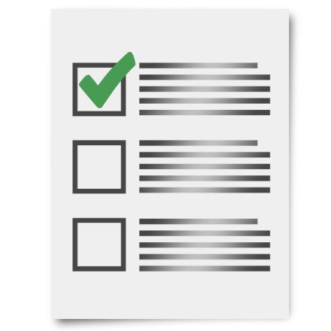 | What to bring to hospital  You should bring to hospital information about  - your medical problems  - health workers you see  - results of medical tests you have had such as blood tests  - medications you take  Medication is sometimes called medicine or drugs.  Medication can be in  - a tablet  - a pill  - a drink  - a needle  Doctors tell people which medicine to take to help make them better.
You can bring your health record if you have one.

This is sometimes called a health folder or health passport.

A health passport is a list of important information about you and your health.

Some people have a health passport to take to different check ups or hospital.
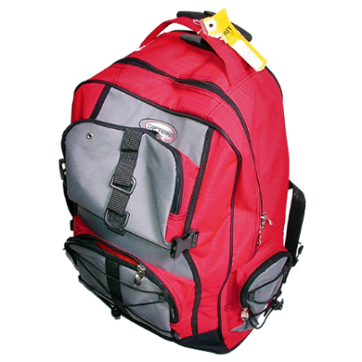 | <Insert list of other items e.g. what clothes/toiletries/personal items to bring>
You can bring a small amount of money with you to hospital

<Suggest $ value> is a good amount.

What you should leave at home

You should not bring lots of money to hospital.

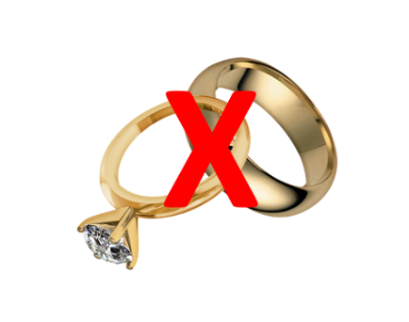 | You should not bring valuable items like jewels that cost a lot of money.  Valuable items can get lost in hospital.  <Insert other items that should not be brought to hospital>
Where to come

The <hospital/unit> is at

<insert address in bold>

The <hospital/unit> is marked on the map you have been given.
 | Come to <reception> and let <insert appropriate person> know your name.
Who to talk to when you have questions

If you have questions you can call <insert appropriate person> on <insert phone number in bold>.

If you have questions you can also email <insert appropriate person> at

<insert email address in bold>

You can also ask someone you trust to call us or email us.

This could be
- a family member
- a friend
- a support person

 | There is a list of what some words mean in this information sheet here or go to www.3dn.unsw.edu.au/projects/easyread

Why I am in hospital and what will happen

This easy read information sheet is about why you are in hospital.

This information sheet is also about what will happen while you are in hospital.

<Use picture of actual hospital/unit  if possible> | Where you are  You are in the <insert name of hospital/unit>.  The <hospital/unit> is in <insert suburb>.
Why you are in hospital

You are here so you can get help with your mental health.

Mental health is about how you think and how you feel.
 | A mental health problem is when feelings start to bother you.
When you have a mental health problem it can change
- how you think
- how you feel
- what you do

For example you can
- have worried thoughts
- feel very sad
- not feel like doing things you enjoy

If you have a mental health problem
it can be hard to cope.
You can ask <insert appropriate person> when you are not sure why you have come to hospital.

<Insert appropriate person> can tell you why you are in hospital.

How long you will stay in hospital

It can be hard to tell how long you need to stay in hospital.

We will keep your stay in hospital as short as possible.

You will stay in hospital until you are well enough to go home.

<Insert appropriate person> will talk to you about how long you will stay in hospital.
<Involuntary version>

Going home

You are an involuntary patient

An involuntary patient is someone who must stay in hospital for mental health treatment until they are well enough to go home.
It is not your choice when you can leave.

You can go home when your doctor says you can.

But you can tell your doctor that you want to go home at any time.

You can get someone you trust to help you to ask or ask for you.

Your doctor will decide if you are well enough to go home.
<Voluntary version>

Going home

You are a voluntary patient.

You are a voluntary patient if you choose to go to hospital for mental health treatment.

You have the choice to leave hospital if you want.
 | Talk to <insert appropriate person> if you want to go home.
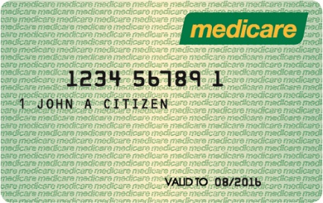 | Money for this hospital stay  If you have a medicare card, you do not have to pay money for this hospital stay.
If you do not have a medicare card
talk to <insert appropriate person> about money you may have to pay.

 | Talk to <insert appropriate person> when you have any questions about why you are in hospital and what is happening.

What happens when I arrive at hospital

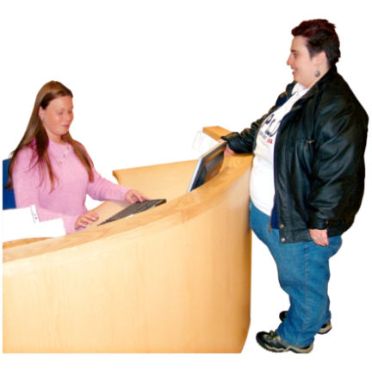 | This easy read information sheet is about what happens first when you arrive at hospital.  <Modify to reflect order of events and add any additional admission procedures>
What happens when I arrive

When you arrive at the hospital <insert appropriate person> will show you
- your room
- the bathroom
- where you eat meals
- the activities room
- where you see your <health care team>
<Insert other applicable places>

[If available] <Insert appropriate person> will give you a map of the <unit/ward>.
 | You will have a name tag on your wrist.
 | You may talk to a doctor soon after you arrive.
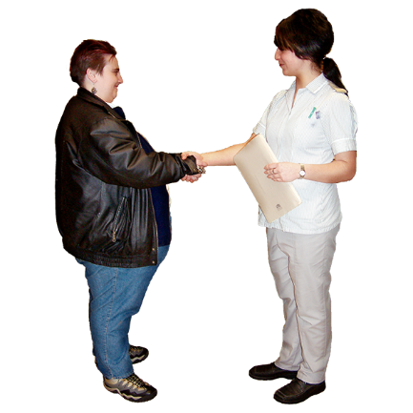 | <Insert appropriate person> will introduce you to people who work at the hospital.  You will meet the people who will care for you while you are in hospital.
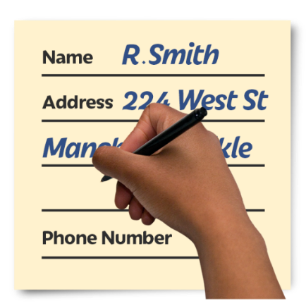 | Filling out forms [If applicable]  You will be asked to fill out these forms  - <Insert appropriate forms>  You will fill out these forms so we know more about you and your health.  Knowing this information will help us to take care of you.
You can ask for more time to fill out these forms.

You can ask someone to help you fill out these forms.
Talk to <Insert appropriate person> if you do not have the information you need to fill out these forms.

<Insert appropriate person> can help you get the information.
Care level

When you arrive at hospital
the mental health workers will talk to you to decide how much care you need.

Mental health workers are people who work to help you with your mental health.
You will be given a care level.

Your care level lets <nurses> know how often they should see you to make sure you are OK.

How often <nurses> see how you are going may change throughout your stay.

Treatment to help my mental health

This easy read information sheet is about treatments for your mental health.

Treatments are things that can help you feel better.
 | Mental health is about how you think and feel.
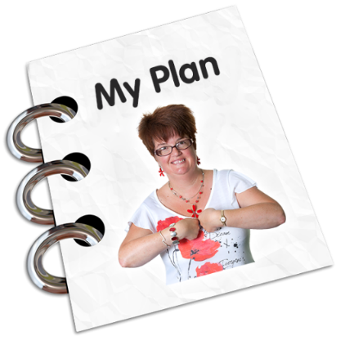 | Treatment plans  A treatment plan is a list of things you can do to help you get better.  A treatment plan is sometimes called a care plan.
Making a treatment plan

You will meet with your <health care team> to talk about your goals for your recovery.

Recovery means getting better so you can do the things you want to do.

Your family and support person may also be at this meeting when that helps you.
You will talk about options for your treatment at this meeting.

You will decide on a treatment plan.

You can tell your <health care team> about your past and current treatments.

<Voluntary version>
You can tell your <health care team> what type of treatment you want.

Your <health care team> cannot give you a treatment if you do not want it.
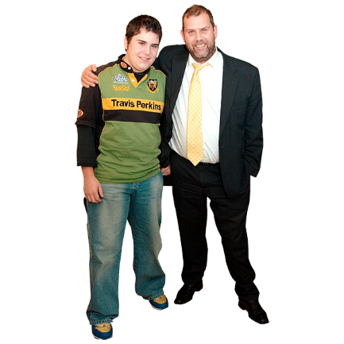 | Some people have a guardian.  A guardian is a person who helps you make decisions about parts of your life when you cannot make decisions by yourself.  If you cannot choose what treatment to have your guardian can decide what treatment would be best for you.
<Involuntary version>
You can tell your <health care team> what type of treatment you would like.

Your <health care team> will try to give you the type of treatment that you want.
You can be given treatment even if you do not want it.

This is because your doctors think it is the best treatment to help you get well.

You must be told what your treatment is.
Treatments this hospital offers

<Insert simple information about treatments offered e.g.>

Talking therapy

Talking therapy is when you talk with a mental health worker to learn ways to cope with how you think or feel.
Mental health workers are people who work to help you with your mental health.

Talking therapy can help you cope with hard problems or worrying thoughts.
Medication

Medication is sometimes called medicine or drugs.

Medication can be in
- a tablet
- a pill
- a drink
- a needle

Doctors tell people which medicine to take to make them better.

Medication is a type of treatment.
Your doctor may give you new medication to take.

If you already take medication
your doctor may change the amount you take.
Your doctor may also tell you to stop taking some medications.

We can give you a sheet with this information written down.

You can write down the changes on your
own medication chart if you have one.
Some medication can give you side effects.

A side effect can make you feel unwell.

Your doctor will tell you how the medication may make you feel.

We can give you a sheet with this information written down.
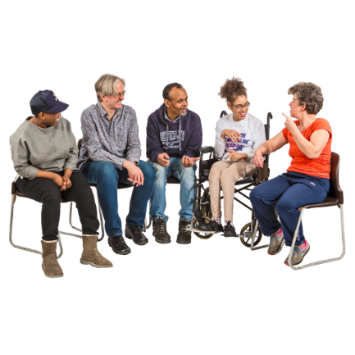 | Support groups  A support group is a small group of people you meet with to talk about mental health.  People usually talk about how they feel and things that make them feel better.
[As applicable]
This hospital has support groups.

You <do/do not> have to attend support groups.

<Insert appropriate person> will tell you when the support groups meet.
Other support groups are outside this hospital.

You will be given information on support groups you can go to when you go home.
What my days will be like in hospital

 | This easy read information sheet is about what you will do each day in hospital.
Meetings

You will talk with people in your <health care team>.

You <can/will> also go to support groups.

A support group is a small group of people you meet with to talk about mental health.

People usually talk about how they feel and things that make them feel better.

Support groups you can go to include <list>
Activities

There are different activities that you can do each <day/weekday>.

These activities will help you learn skills and feel better.

Activities you can do include
- <Insert simple list>

You must take part in <all/percentage of meetings and activities>.
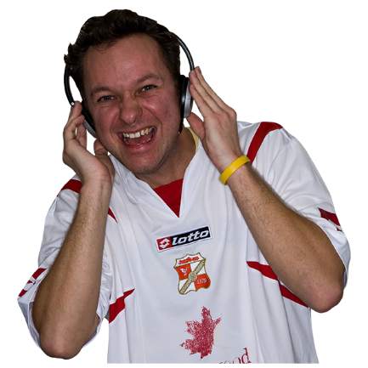 | Relaxing  You have free time each day.  Things you can do during free time include  - <Insert simple list of activities>
Sleep

A good night of sleep is important to help you feel good.

It is best if you go to sleep at the same time each night.

You can tell your <health care team> when you have trouble sleeping.

Your <health care team> can help you with ways to sleep better.
Exercise

Exercise is important to help you feel good.

This <hospital/unit> has an exercise program.

It is good for you to join the exercise program.
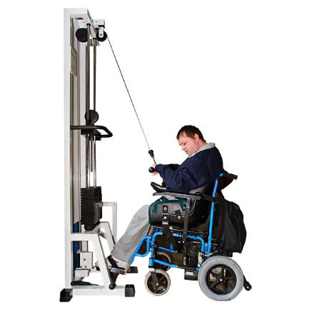 | [If applicable] You can use the hospital gym.  Ask <appropriate person> how to use the gym.
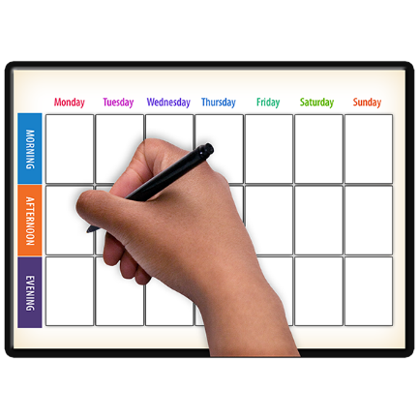 | We can write down your activities and meetings for each day.

Mental health workers who work in this hospital

 | This easy read information sheet is about the mental health workers who work in this hospital.
Mental health workers are people who work to help you with your mental health.

Mental health is about how you think and how you feel.

<Insert brief descriptions of applicable mental health workers e.g.>

Psychiatrists

A psychiatrist is a doctor who helps you with your mental health.

A psychiatrist will be in charge of your care.
Psychiatrists can prescribe medicine.

To prescribe means to recommend and say it is OK for you to take some kind of medicine.

Psychiatrists can tell you which medicine to take to make your mental health better.
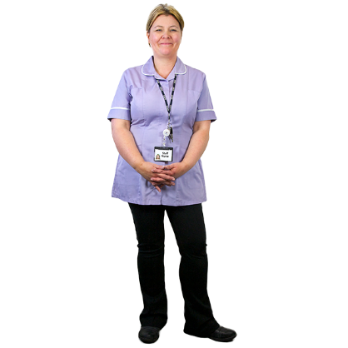 | Mental health nurses  Mental health nurses are the main people who will look after you each day in hospital.  A mental health nurse may give you medicine.  A mental health nurse can also help you with things like having a shower and getting dressed.
Psychologists

A psychologist helps you with your mental health by talking with you.

Psychologists help you find things you can do to feel better.

Psychologists do not give you medication.
Social workers

A social worker is a mental health worker who helps you find the support you need to stay well.

You can talk to a social worker when you need information about services or support for you or your family.
Occupational therapist

Occupational therapists help people take part in daily activities and support them to learn new skills.
Case managers

A case manager is a health worker who helps plan and organise your care and other services you will get.
Peer workers

A peer worker is someone who has a lived experience of mental health problems.

A peer worker can support you and help advocate for you.

Dieticians

A dietician helps you to choose the best foods to eat so you can be healthy.
Exercise physiologist

An exercise physiologist suggests exercises you can do to get healthy.

These exercises can help with any illnesses or injuries you may have.
Details of your <health care team>

Your <health care team> has mental health workers who will care for you and provide your treatments.

Treatments are things that can help you feel better.
We will write down the names of your <health care team> on a sheet.

We will also write down when you will meet with people in your <health care team> on this sheet.

How the hospital workers should treat me

This easy read information sheet is about how hospital workers should treat and care for you.

All hospital workers should treat you with respect.

Respect is showing care about who you are and what is important to you.

Hospital workers must treat you with dignity.

Dignity is to treat you with respect.

Dignity is also to give you as much privacy as possible.

An example of dignity is someone knocking on your door before they come into your bedroom.
Hospital workers should give you as much choice as possible when you are in hospital.

Hospital workers should have your needs and wants in mind when making decisions about your treatment.

Treatments are things that can help you feel better.
Confidentiality

Hospital workers must follow rules around confidentiality.

Confidentiality means information about you that people should not share with others.

Your <health care team> only share confidential information when
- you say it is OK or
- when there is a good reason or
- when the law says they must
Privacy

Hospital workers must follow rules around privacy.

Privacy means other people cannot see or hear things about you that you do not want them to know.

For more information on how hospital workers should treat you see the My rights information sheet.
You can tell someone if you are not happy with how hospital workers treat you.

See the When I am worried about how I am being treated information sheet for what you can do.

Support from people I trust

This easy read information sheet is about how the people you trust can support you while in hospital.

This could be
- your family
- your friends
- your support people
How people you trust can be involved in your treatment

Your <insert appropriate person> will talk with you about how people you trust can be involved in your treatment.

Treatments are things that can help you feel better.

Your family or support person can provide extra information about you when that helps you.
 | If you do not want your family or a support person to be involved in your treatment, that is OK too.
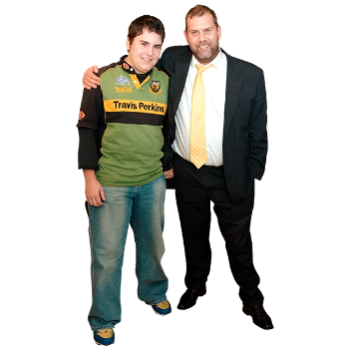 | However, some people have a guardian.  A guardian is a person who helps you make decisions about parts of your life when you cannot make decisions by yourself.  A guardian may need to be involved in decisions about your treatment even if you do not want them to be.
People you trust can also support your mental health when you go home if that helps you.

Mental health is about how you think and how you feel.

Your family, friend or support person may notice if you feel sad or worried and should call your <Insert appropriate person>.
Visiting you in hospital

People you trust can visit you in hospital if you want.

This could be
- a family member
- a friend
- a support person

You can <call/email> your family, support person, or friends to arrange their visit.

Visiting hours are
<insert days and times>
You can meet with the people who visit you in <insert locations>.

People who visit you cannot go into <insert locations if applicable>.
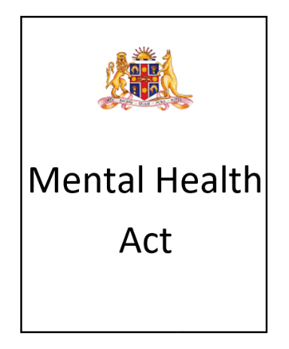 | Information that people you trust can be given  The Mental Health Act is the rules about mental health treatment in NSW.
 | The Mental Health Act says you can choose who you would like to be your designated carers.
A designated carer is a person who you have chosen to be told information about your mental health and hospital stay.

You can choose 1 or 2 people to be your designated carers.

Designated carers are people who you know well.
You or your doctor will decide who your principal care provider is.

Your principal care provider is the main person who helps or cares for you when you are at home.

Your doctor will not choose someone you do not want information given to.
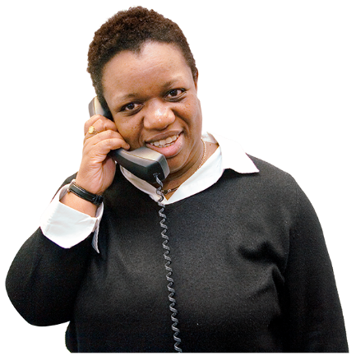 | Your designated carers and principal care provider will be told  - that you are in hospital  - what treatments you will be given  - when you go to another hospital  - when you leave hospital  - about plans for your care after you go home
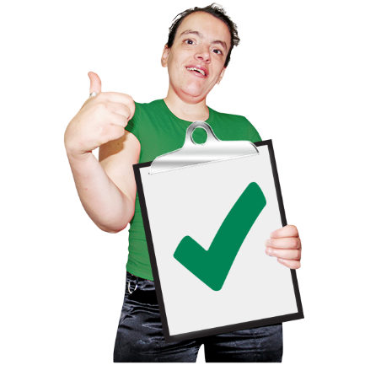 | Your <health care team> can give other people information about you if you say it is OK.

My rights

This easy read information sheet is about your rights when you are in hospital.

You have rights about how other people must treat you.

When you are in hospital you have the following rights.
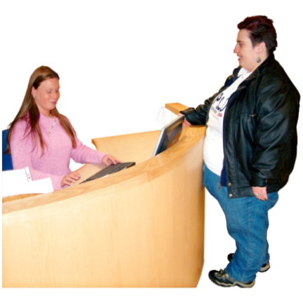 | Access  You have the right to get health care.
Safety

You have the right to high quality health care that will not hurt you.
Respect

You have the right to be treated with respect by hospital workers and other people staying in the hospital.

Respect is showing care about who you are and what is important to you.
Dignity

Hospital workers must treat you with dignity.

Dignity is to treat you with respect

Dignity is also to give you as much privacy as possible.
Information

You have the right to be given information about your care and services in a way you understand.
Being included

You have the right to be included in talks about your health care.

Your wishes should be considered when possible.
Confidentiality

Anything you tell hospital workers will be kept confidential.

Confidential means information about you that people should not share with others.

Your <health care team> only share confidential information when
- you say it is OK or
- when there is a good reason or
- when the law says they must

Your <health care team> would only share information about you if
- you said they can tell a family member or support person
- they need to get help to stop you or another person getting hurt
- when they need to for your treatment
- the law says they must

Privacy

Privacy means that other people cannot see or hear things about you that you do not want them to know.

For example your medical records are kept safely locked away.

Have your say

You have the right to have your say on the health care you get.

You have the right to ask questions about your health care.
You have the right to make a complaint if you are not happy with the health care you are getting.

A complaint is when you tell someone you are not happy with something.

You can find more information about making complaints in the information sheet When I am worried about how I am being treated.

My duties while in hospital

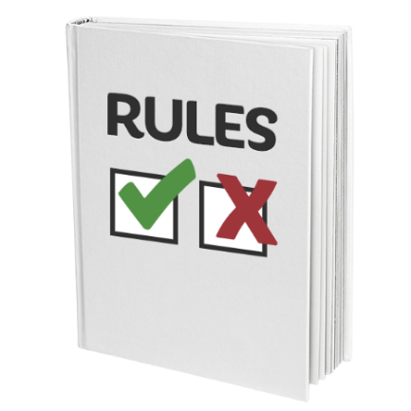 | This easy read information sheet is about your duties while you are in hospital.  Duties means things that you should do and rules you should follow.
Treat other people well

Other people who stay in the hospital may tell you personal things.

Do not repeat what they tell you to other people.
 | Do not take photos of other people staying or working in the hospital.
 | Do not put information on social media or the internet about people who are staying or working in the hospital.
Getting along with others

Everyone in this hospital should feel comfortable and safe.
 | Do not say hurtful things to other people.
 | Do not physically hurt other people.
 | Do not touch or use other people’s things unless they have said you can.
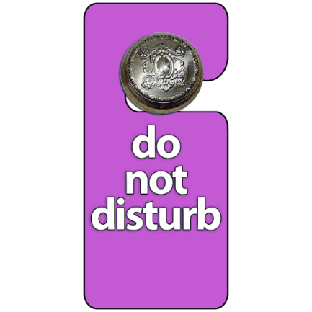 | Give people their personal space.  This means do not go into other people’s bedrooms.
It also means do not touch other people.

<Insert any other rules e.g. no borrowing etc>
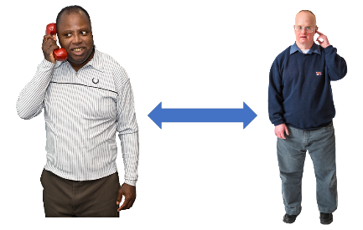 | When someone is on the phone you should not stand too close to them.  You should not listen to what they are saying.
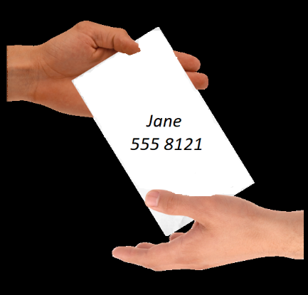 | Personal and sexual safety  Be careful giving your phone number or address to other people.  You can talk to someone you trust about this if you want.
Sexual relationships are <not allowed/not suggested- insert rules> at <hospital/unit>.

You should tell a hospital worker if another person touches you or makes you feel uncomfortable.

You should tell a hospital worker straight away if anyone wants you to take part in sexual activity.

The hospital worker can help you.
Safety

<Insert procedure and who to talk to> if you do not feel safe at any time.
 | You can lock your personal items away in <insert location> so they do not get taken.
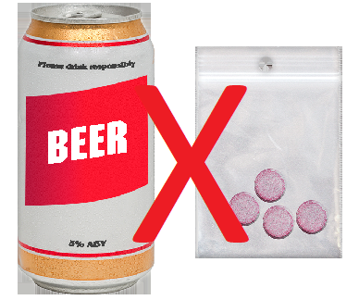 | Drugs and alcohol  You are not allowed to bring drugs or alcohol into <hospital/unit name>.  If you have drugs or alcohol with you <insert measures>.  We will need to tell the police if you have any illegal drugs with you.  Illegal drugs are ones that the law does not allow you to have.
Talk to your <health care team> if you usually use alcohol or drugs.

Your <health care team> will work out a plan with you to help you feel comfortable.
Smoking

Smoking is not allowed in this hospital.

If you smoke, please talk to <insert appropriate person>.
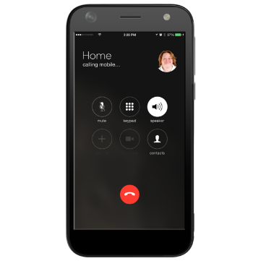 | Mobile phones and cameras  You <can/cannot> bring your mobile phone into this <hospital/unit>.  [If allowed]  You must take care of your phone.
 | You cannot use the camera on your phone in this <hospital/unit>.
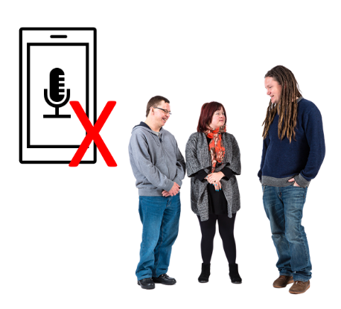 | You cannot use your phone to record conversations.

Daily life in hospital

This easy read information sheet is about day to day life while you are in hospital.

It will help you know
- what you can have in hospital
- what you can use around the hospital
- what you need to do while in hospital
Personal items you can have in hospital

You can have some of your own things with you while you are in hospital.

You can ask a family member or friend to bring personal items to you.

You can have
<Insert list of items e.g.>
- clothes
- toiletries
- personal items
You can have a small amount of money with you in hospital.

<Suggest $ value> is a good amount to have.

You can buy <insert what, when and where>.
Items you should not have in hospital

You should not have lots of money with you in hospital.
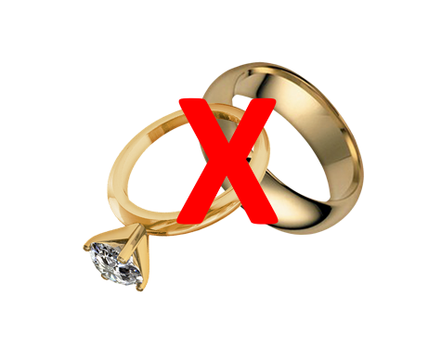 | You should not have valuable items with you in hospital.  They can get lost.  Valuable items are things like jewels that costs lots of money.  <Insert other items that should not be brought to hospital>
What you can use around the hospital

<Insert brief details on facilities available e.g.>

You can use the television room.

The television room is in <location>.

You can watch television anytime from <insert times>.
A phone is in <insert location>.

You can use the phone <insert times>.

You <have to/ do not have to> pay to make calls.

Please keep calls to <insert length> so other people can use the phone.
You can use the kitchen.
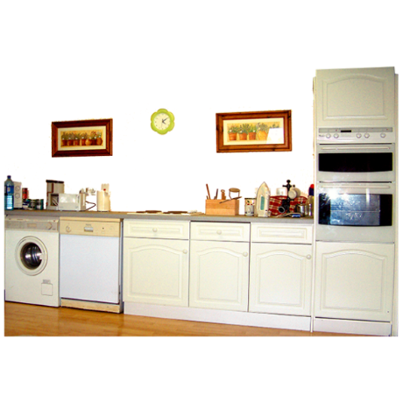
The kitchen is located <insert location>.

You can get a drink or a snack in the kitchen.

You can get a drink or a snack any time from <insert times>.
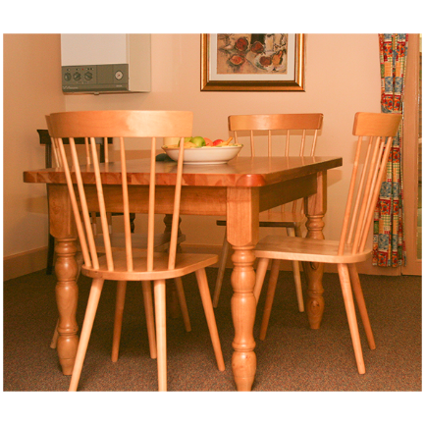 | Meals  You are given meals in hospital.  Meals are served in the dining room.  You will be shown the dining room.  Meal times are  - breakfast <>  - morning tea <>  - lunch <>  - afternoon tea <>  - dinner <>
 | Tell <Insert appropriate person> if there are foods you do not eat.
You should eat any food you have while it is fresh.

Ask <appropriate person> if you have questions about storing your food.
Cleaning <amend as necessary>

Please keep your room tidy.

Hospital cleaners will clean your room.

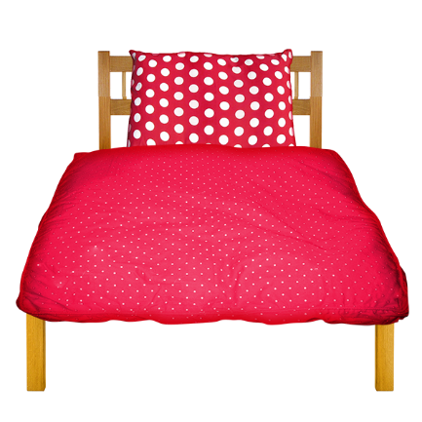 | You should change your sheets, pillowcase and towels once per week.  You can ask <Insert appropriate person> for help to change your sheets, pillowcase and towels.
Laundry <amend as necessary>

You can use the washing machine and dryer to wash your clothes.

You will be shown the laundry room.

You can use the laundry powder.

You will do your own laundry.

Ask <Insert appropriate person> if you need help with your laundry.

My day and time to do my laundry is: Day__________
Time____________

Leave from hospital

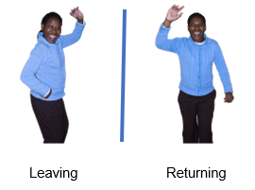 | This easy read information sheet is about leave from hospital.  Leave means that you can go out of the hospital for a while and come back.
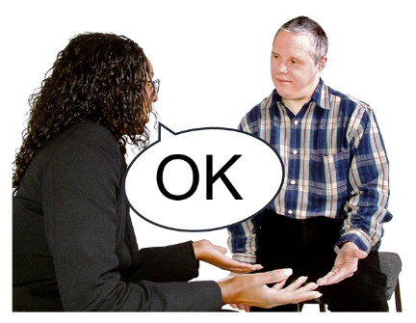 | <Involuntary version>  You are an involuntary patient.  An involuntary patient is someone who must stay in hospital for mental health treatment until they are well enough to go home.  This means you can only leave the hospital if your <health care team> says it is OK.  You may be given leave later in your stay in hospital.  Your <health care team> will talk with you about the type of leave that is best for you.  They may also talk to your family and support people.
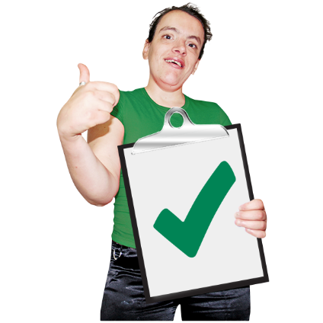 | <Voluntary version>  You are a voluntary patient.  As a voluntary patient you can leave the hospital if you want.
Your <health care team> need to know you are leaving.

You should talk to your <health care team> about options for leave.

Leave should be arranged before your planned outing from the hospital.

You still need to be back in time for appointments with your <health care team>.
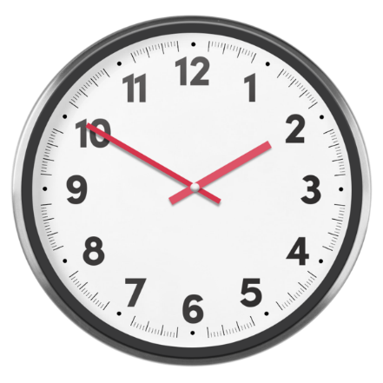 | <All>  If you go on leave it is important that you come back to hospital on time.  If you will be late you need to call <insert appropriate person> on <insert phone number in bold>.

Going home at the end of my stay in hospital

 | This easy read information sheet is about what will happen when you go home at the end of your stay in hospital.
Going home

Your <health care team> want to make sure you have recovered enough to go home.

Recovered means getting better so you can do the things you want to do.
Your <health care team> will talk with you about going home from hospital.

You can ask <Insert appropriate person> about going home.

To leave hospital is also called discharge.
Your plan to go home

Your <health care team> will help you make a plan to leave hospital.
Help you will have when you go home

Your <health care team> will talk with you about help you will get when you are at home.

You can ask your <health care team> questions about what happens when you go home.

Your discharge plan will list the treatment and support you will get when you go home.

Treatments are things that can help you to feel better.
Doctors tell people which medication to take to help make them better.

Medication is sometimes called medicine or drugs.

Medication can be in
- a tablet
- a pill
- a drink
- a needle

If you take medication we will give you <medication to take home/a prescription for further medication>.
Your <Insert appropriate person> will keep in contact with you when you are at home.

<Insert appropriate person> might
- call you on the phone
- email you
- visit you at home

You can ask <Insert appropriate person> questions and they will give you help.
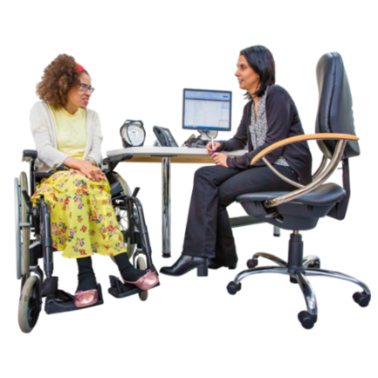 | We will send your discharge plan to your general practitioner.  Your general practitioner is your regular doctor.  They are also called your GP.  You should keep seeing your GP regularly.
 | We will give you a list of phone numbers you can call when you have questions or need help.

When I am worried about how I am being treated

This easy read information sheet will help you if you are worried about how you are being treated in hospital.

It will tell you
- who you can talk to
- how to make a complaint if you are not happy
Who you can talk to in hospital

You can talk to <Insert appropriate person>.

You can <insert details how they can talk to them>.
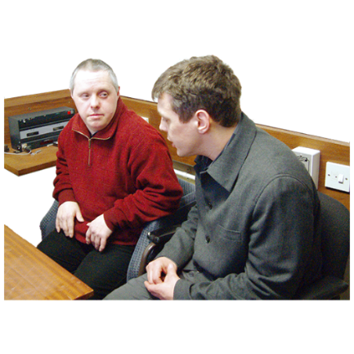 | You can talk to <Insert appropriate person at hospital> if you are not happy with what <Insert appropriate person> says and does.  You can talk to <Insert appropriate person> by <insert details>.
If you do not want to talk to hospital workers that is OK too.

You can talk to other people.

You can also talk to
- your family
- your friend
- your support person

Official Visitors

Official Visitors are people who visit the hospital.

Official Visitors make sure people in hospital are treated well.

Official Visitors do not work for the hospital.

You can tell an Official Visitor your ideas on how the hospital can treat you better.

You can make a complaint with the Official Visitor.
 | A complaint is when you tell someone you are not happy with something.
All complaints are confidential.

Confidential means information about you that people should not share with others.

This means only people who are dealing with the complaint will know about it.

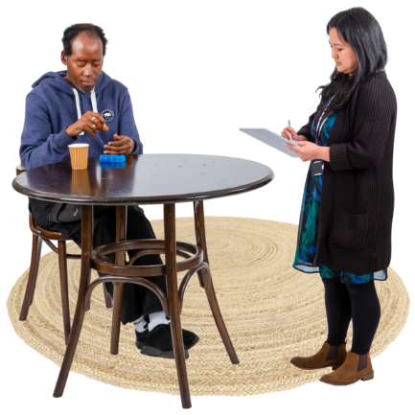 | You can talk to an Official Visitor when they visit your hospital.  You do not have to talk to an Official Visitor if you do not want to.  You can ask someone you trust to tell the hospital workers you would like to talk to the Official Visitor.  This can be  - a family member  - a friend  - a support person
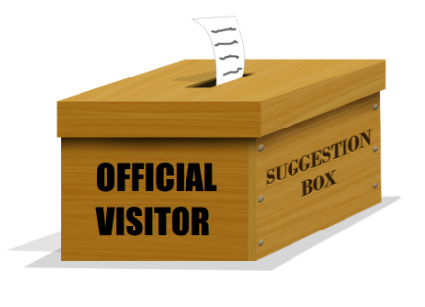 | You can leave a letter in the Official Visitors box.  The Official Visitors box is a locked box on the ward.  <Insert appropriate person> can show you where the Official Visitor box is.  Only Official Visitors can read the letters in this box.
If you want to talk to an Official Visitor you can also call 1800 208 218.

This call does not cost money.
To write to an Official Visitor you can email

OfficialVisitorsProgram@health.nsw.gov.au
For more information about Official Visitors see the website
https://officialvisitorsmh.nsw.gov.au
Other ways you can make a complaint

You can also make a complaint by talking or writing to other people.
You can talk to <Insert appropriate person> when you want to make a complaint.

You can talk to <Insert appropriate person> by <insert details e.g. phone number in bold>.
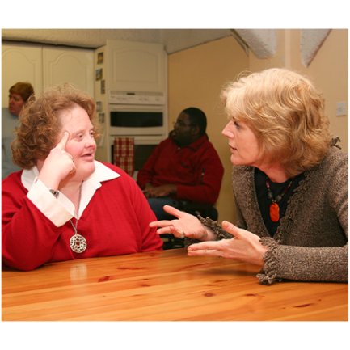 | You can make a complaint to < Insert appropriate person> when you are not happy with what <Insert appropriate person> says and does.  You can talk to <appropriate person> by  <insert details e.g. phone number in bold>.
If you do not want to make a complaint to hospital workers that is OK too.

You can make a complaint to other people.

You can contact the Health Care Complaints Commission when you do not want to talk to hospital workers.

You can also contact the Health Care Complaints Commission when you are not happy with what <Insert appropriate person> says and does.
 | You need to make complaints to the Health Care Complaints Commission in writing.
You can ask someone you trust to help you write the complaint.

You can ask
- a family member
- a friend
- a support person

The Health Care Complaints Commission can also help you write your complaint.

You can call them on 1800 043 159.

This call does not cost money.
 | You can fill in a form at this website https://ecomplaints.hccc.nsw.gov.au/.
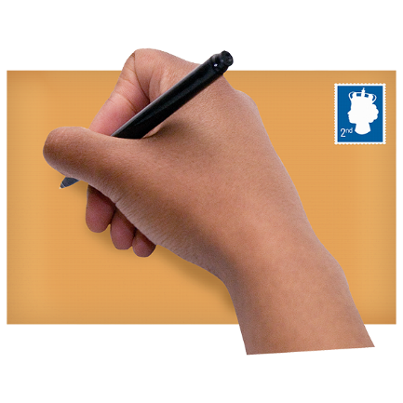 | You can also send the complaint in writing to  Health Care Complaints Commission  Locked Mail Bag 18  STRAWBERRY HILLS NSW 2012
Or by email to

hccc@hccc.nsw.gov.au

For more information you can visit the Health Care Complaints Commission website at

www.hccc.nsw.gov.au
You can ask someone you trust to make a complaint for you.

This could be
- a family member
- a friend
- a support person
- a hospital worker

Information I would like about my hospital stay

 | Information about | This is important to me  Tick
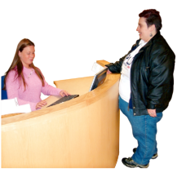 | Information about going to hospital
 | Why I am in hospital and what will happen
 | What happens when I arrive at hospital
 | Treatment to help my mental health
1
What my days will be like in hospital

Mental health workers who work in this hospital
How the hospital workers should treat me
Support from people I trust
My rights
2
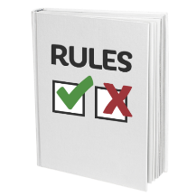 | My duties while in hospital
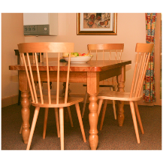 | Daily life in hospital
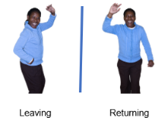 | Leave from hospital
 | Going home at the end of my stay in hospital
 | When I am worried about how I am being treated
3

My Medications

Medication is sometimes called medicine or drugs.
Medication can be in
- a tablet
- a pill
- a drink
- a needle
Doctors tell people which medicine to take to help make them better.
Medication name | What I take this medication for | When I take this medication | How this medication may make me feel
Date
Daily Planner
Meeting or activity | Time | What this is | Where I need to go | I have been  Tick

Activities I could do in my free time
Some examples |  | You can write or draw activities you would like to do here
 | dance
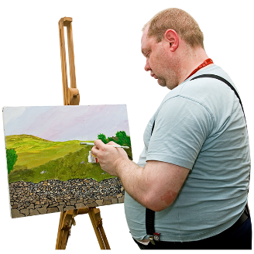 | art
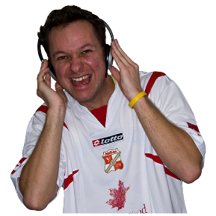 | listen to music

My health care team
Photo | Name | What they do | When I see them | Where I see them

Introduction to Inpatient Mental Health Services

Authors
Janelle Weise¹, Bronwyn Newman¹, Claire Eagleson¹, Karen Fisher², and Julian Trollor¹.

¹Department of Developmental Disability Neuropsychiatry, School of Psychiatry, Faculty of Medicine, UNSW Sydney
²Social Policy Research Centre, Faculty of Arts and Social Sciences, UNSW Sydney

This information sheet is part of a series of easy read resources explaining
- how people can access public mental health services in New South Wales and
- what they can expect.

For information on how to support people to use easy read see Making mental health information accessible for people with intellectual disability – A Toolkit

© Department of Developmental Disability Neuropsychiatry UNSW Sydney 26.11.20 v1

