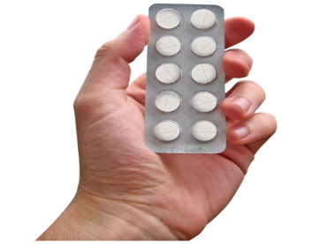
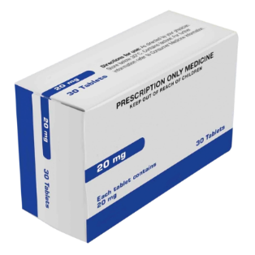
My Medications

Medication is sometimes called medicine or drugs.
Medication can be in
- a tablet
- a pill
- a drink
- a needle
Doctors tell people which medicine to take to help make them better.
Medication name | What I take this medication for | When I take this medication | How this medication may make me feel

My Medications

Authors
Janelle Weise¹, Bronwyn Newman¹, Claire Eagleson¹, Karen Fisher², and Julian Trollor¹.

¹Department of Developmental Disability Neuropsychiatry, School of Psychiatry, Faculty of Medicine, UNSW Sydney
²Social Policy Research Centre, Faculty of Arts and Social Sciences, UNSW Sydney

This planning sheet is part of a series of easy read resources explaining
- how people can access public mental health services in New South Wales and
- what they can expect.

For information on how to support people to use easy read see Making mental health information accessible for people with intellectual disability – A Toolkit

© Department of Developmental Disability Neuropsychiatry UNSW Sydney 26.11.20 v1

