Dementia in People with Intellectual Disability
  - Information for families, friends & carers

Written by Dr. Liz Evans and Professor Julian Trollor.
Department of Developmental Disability Neuropsychiatry, Discipline of Psychiatry and Mental Health, School of Clinical Medicine, UNSW Medicine and Health, Sydney.
© Department of Developmental Disability Neuropsychiatry UNSW, 2020.

This booklet is licensed under a Creative Commons Attribution Non-commercial No Derivatives 4.0 International License. You may freely use and reproduce this material if you say where it came from, provided you don’t charge for it. If you would like to adapt the content, please email dddn@unsw.edu.au .
Disclaimer: All photos are stock photos. Posed by models.
Acknowledgements: Thank you to the people who contributed their time during the consultations to develop and refine this resource.
Dr. Evans’ work on this booklet was funded by an NHMRC-ARC Dementia Research Development Fellowship.

Introduction
People with intellectual disability may be at higher risk of developing dementia as they age. But getting an earlier diagnosis can lead to better care planning, and earlier access to dementia services.
This booklet is intended for families and carers of people with intellectual disability living in Australia. It provides information about:
- What dementia is
- How dementia affects people with intellectual disability
- The higher risk of dementia for people with Down syndrome
- What to do if someone you know shows signs of dementia
- How to reduce the risk of dementia
- Other helpful resources.
At the end, you will find:
- space for you to record notes
- links to other sources of information.
Links to international resources, and to information about dementia more generally, are at the end of the book.

What is dementia?
The term dementia doesn’t refer to one specific disease. It is a broad term used to describe a set of conditions which result in a decline in the person’s mental abilities – their capacity to think, reason, and remember.
Most people with dementia will experience changes like:
- declines in memory - with more recent information or events being harder to remember
- difficulty concentrating
- difficulty finding the correct words to say
- reduced ability to plan and make good decisions
- feeling less motivated
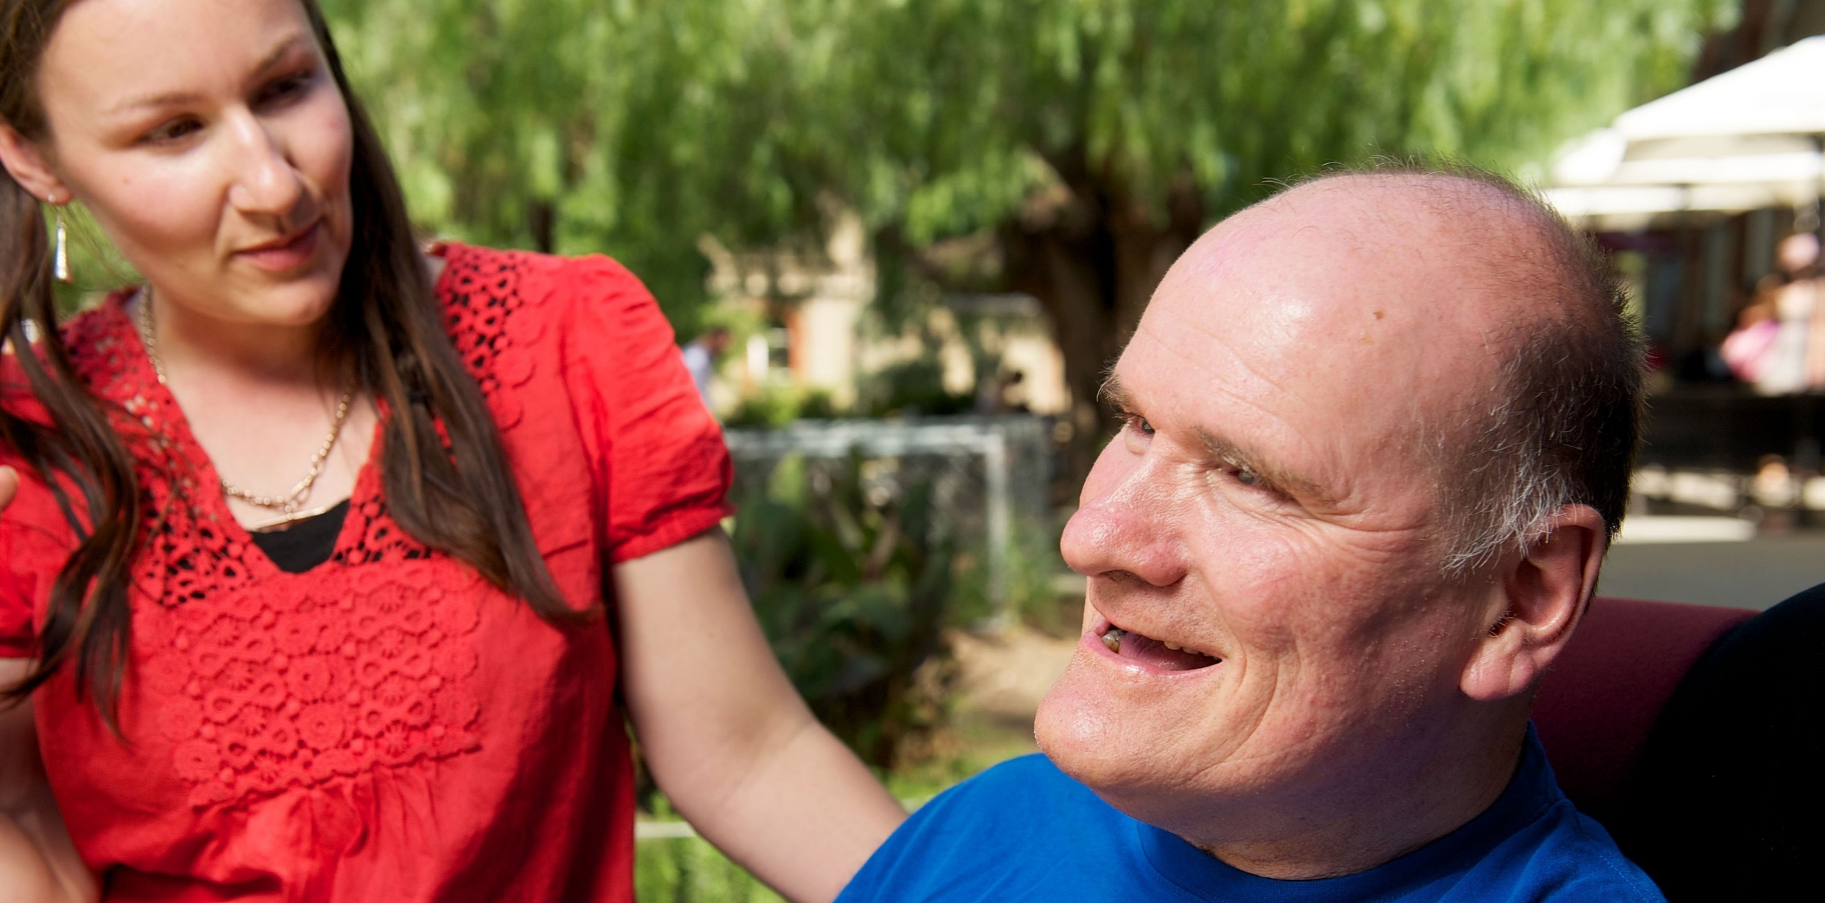
- personality and behaviour changes.
Most conditions that cause dementia have no cure. In most cases, a person’s abilities continue to decline over time. However, there is support available for people who have dementia, and their families and carers.

Dementia is NOT a normal part of ageing
It is normal for the brain to slow down a little as a person ages, making it a little harder for them to do their usual activities. When a person has dementia, there is a marked change in thinking skills – much more than is typical for their age.

Examples of signs of normal ageing and signs of dementia:
A person showing normal signs of ageing may … | A person who has dementia may …
…find their thinking becomes a little slower | …become much slower to think and complete tasks
…have a little more trouble remembering things. For example, they may need to check their diary more often to remember appointments | …entirely forget recent events, having no memory of them even after someone reminds them
…have trouble recalling a name, but remember it later | …forget a friend or family member’s name
cope well with everyday tasks, unless their physical health problems stop them | lose the ability to do their usual activities, for no apparent reason

Types of dementia and terms used

Types of dementia
There are many types of dementia. They are caused by different disease processes, and each has a slightly different set of symptoms.
Alzheimer’s disease is the most common cause of dementia. People with Alzheimer’s disease have ongoing memory loss and a gradual decline in other skills, such as finding the right words for everyday objects, changes in emotional regulation, and loss of initiative. Their brains show a build-up of certain proteins.
Vascular dementia is caused by reduced or blocked blood flow to the brain due to health problems like mini-strokes. The symptoms of vascular dementia vary widely, depending on the parts of the brain affected. However, it typically results in problems in reasoning and thinking skills, and for some people, memory loss.
Frontotemporal dementia affects a person’s personality, behaviour and language skills, before it affects their memory.
Lewy body dementia causes problems with thinking and movement, fluctuating levels of confusion and concentration, difficulty judging distances, along with hallucinations (seeing, hearing or smelling things that are not present).
There are many other causes of dementia. Some of the more common ones are excessive use of alcohol or other drugs, repeated head injury, vitamin deficiencies, and infections or inflammation affecting the brain.
Mixed dementia is a mix of one or more types, and is very common.
Late onset dementia and Younger onset dementia
Dementia is more likely to develop in older adults. When the symptoms begin after the age of 65, it is known as ‘late onset dementia’, but it is often referred to as simply ‘dementia’.
However, dementia can also occur people under the age of 65. When it does, it is called ‘younger onset dementia’ or ‘young onset dementia’.

Neurocognitive disorder
“Major neurocognitive disorder” is a new term for dementia.
“Minor neurocognitive disorder” and “Mild cognitive impairment” both refer to a milder decline in thinking skills. For some people, this may be the beginning of dementia, and their skills will decline further over time. For others, thinking skills will not decline further, and some will recover to their previous level of skills.
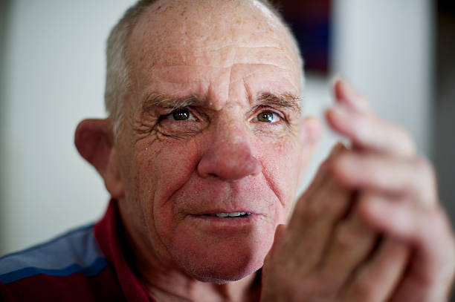

What is the risk of dementia for people with intellectual disability?
People who have Down syndrome have a much higher risk of developing dementia, particularly Alzheimer’s disease, compared with the general population. Not all people with Down syndrome will get dementia. When they do, it tends to start at a younger age than for the general population. The rates of dementia vary between research studies. One study found fewer than 10% of people with Down syndrome are diagnosed with dementia in their 40’s, while another found a rate of over 80% in people with Down syndrome aged above 65. The average age for people with Down syndrome to be diagnosed with dementia is the mid-50’s.
Scientists believe this higher risk is due to a gene on chromosome 21 which plays a major role in the brain changes associated with Alzheimer’s disease. People with Down syndrome have 3 copies of chromosome 21, whereas most people have 2 copies. Genes are a code for proteins, and since most people with Down syndrome have three copies of this gene, they produce more of the protein on this gene that is thought to be associated with risk of Alzheimer’s disease. As a result, virtually all people with Down syndrome have some changes in their brain by about the age of 40. But most won’t show outward signs of dementia for some years after this.
Studies focused on people with intellectual disability who do not have Down syndrome have found differing rates of dementia. However, overall, it appears they may be at a somewhat increased risk of dementia, particularly younger onset dementia, than people the same age without intellectual disability. There is not much research on dementia risk in other groups, such as people with intellectual disability and autism.

What are the signs of dementia in people with intellectual disability?
The early signs of dementia in people with intellectual disability can be different, compared with people without intellectual disability.
The signs of dementia can vary, and can depend on:
- a person’s level of intellectual disability
- their usual mood, behaviour and activities
- whether they have a specific syndrome such as Down syndrome or Rett syndrome.

Common early signs of dementia in people with intellectual disability:
- Changes in behaviour
Examples: increased irritability, aggression, or self-injury
- Changes in personality
Examples: increased stubbornness, irritability; prolonged sadness, loss of interest or motivation for their usual activities; reduced social engagement
- Declines in functional abilities
Examples: less attention to personal hygiene; difficulty doing their usual tasks at home, work or at a day program
- Changed thinking skills
Examples: confusion; trouble concentrating; less able to follow a plan; unable to find objects; more difficulty reading
- Declines in memory – especially recent events or information.
In people with Down syndrome, changes in behaviour and personality are often the first signs of dementia noticed by family or friends.

Changes do not always mean a person has dementia
Many of the signs of dementia can also be caused by other conditions.
These include:
- Changes in vision or hearing
- Thyroid problems
- Low levels of specific vitamins
- Sleep disorders, such as sleep apnoea
- Another physical health problem, or a response to untreated pain
- Mental health problems like depression
- Side effects from medications – this can occur even if the person has been taking the medication for some time.
Many of these conditions are treatable.
Some of these conditions are also more common in people with intellectual disability than people without intellectual disability. People with intellectual disability have a higher rate of physical and mental health problems, and may be at higher risk of medication side effects.
Any time a person shows persistent changes in their behaviour, personality, or declines in their thinking, they need to see their doctor.
The reasons for the changes need to be investigated promptly.
Whether changes turn out to be due to dementia, or due to another condition, an earlier diagnosis usually means a better outcome.

The benefits of early help-seeking for dementia
If changes do relate to dementia, the journey towards a formal diagnosis is often lengthy. For people without intellectual disability, the time from first noticing concerns through to receiving a diagnosis may be up to 2 years. This is because dementia is not simple to diagnose. It can be even more complex where someone has an intellectual disability. Doctors may need to do several tests, and might want to monitor the person over time before making a diagnosis.
However, during this waiting time, a person may be diagnosed with ‘suspected dementia’. This should allow them to access increased supports. It also means a specialist can prescribe them medications reserved for people with dementia, if indicated.
Commencing investigations early means that formal tracking of the person’s skills can begin earlier, not later, which can enable an earlier diagnosis.
An earlier diagnosis can allow the person to be included in decisions about their care as much as possible – before their thinking skills change further. Earlier help-seeking can also mean there is more time:
- for the person, and those supporting them, to learn about dementia and what to expect - helping everyone to cope better
- to explore and discuss options for meeting their future care needs
- to try different management strategies.

What to do if someone shows signs of dementia
If you are concerned about signs of dementia in a person with intellectual disability that you know, support them to seek help.

Talk to the person, and any other people involved
Speak with the person in a manner that is appropriate for your relationship with them, and for their understanding and communication. Offer to support them to see their doctor. If they have an appointed guardian or a relative who regularly supports them to make decisions, involve that person, too.

Document changes you’ve noticed, and what is typical for them
The Early Detection Screen for Dementia is a checklist focused on changes in an adult with intellectual disability. It should be completed by someone who has known the person for some time. It can be downloaded here: https://www.the-ntg.org/ntg-edsd .
The Wellbeing record is a good way to record changes in more detail. On it, there is space to write about:
- their ‘normal wellbeing’ –how they functioned before any changes
- observed changes – whether or not they relate to dementia.
If the person already has a Wellbeing Record, update it with the changes you’ve seen. Involve the person with intellectual disability as much as possible in this process. If they agree, you could also ask for information from other people who regularly spend time with them.
If they don’t yet have a Wellbeing Record, you can download it here: http://unsw.to/3dn_carers .
Keep these forms somewhere safe for future reference.

Support them to see their GP
Ask for a long appointment at the time of booking. If the person is due for their annual health check, they can ask for a long or prolonged annual health assessment under Medicare.
What will the GP do?
The GP should listen the concerns raised and review the changes documented in the Early Screen and Wellbeing Record forms. The GP should show respect to the person with intellectual disability and involve them as much as possible in all conversations.
A person with intellectual disability who is experiencing changes should receive a full medical check. This will include reviewing all their medications, checking their vision and hearing, and getting a blood test, to check for other possible causes of declines.
Depending on what information is already at hand, the GP may wish to gather further information and ask questions of other people, with appropriate consent. They may ask about environmental changes that occurred around the same time as the changes in skills or behaviour.
If symptoms or test results suggest medical issues requiring further investigation, they may refer the person for further evaluation with a specialist. If dementia is suspected, a referral may be made for a dementia assessment.

What does a dementia assessment involve?
A dementia assessment investigates a person’s symptoms in more detail.
It seeks to uncover the extent and nature of declines in skills.
This usually includes a review and further testing if needed, along with an informant report, and wherever possible, a cognitive assessment.
Detailed Review:
All information about the person, and the declines in their skills will be reviewed in more detail, including looking at:
- the timing of particular changes
- other health problems or environmental changes that occurred around the same time.
Further tests:
The assessment may also involve further tests, such as a brain scan (CT or MRI) to look at possible causes of changes in thinking.
Informant report:
An important part of a dementia assessment is gathering additional information from an informant. The best informant is someone who has known the person well over a number of years. This might be a family member, friend, or long term support worker.
Cognitive assessment:
Where possible, the assessment should include a detailed cognitive assessment - a test of the person’s thinking skills in the areas most commonly affected by dementia.
The standard tests used for the general population are not suitable for people with intellectual disability. The abilities of different people with intellectual disability vary greatly, even when they don’t have dementia. So a dementia cognitive assessment for a person with intellectual disability will typically aim to compare their skills now with their own skills before changes occurred.
If a person has previously had a cognitive assessment that tested the types of thinking skills affected by dementia, it may be possible to repeat that test to measure changes. If they have not yet had such a test, then another option is to complete an assessment, and then repeat it 6 to 12 months later – to track changes over time.
However, a person’s test scores are affected by many things, and so they can change for various reasons – not just dementia. So, in some cases, it may be necessary to wait and test a person’s skills a third time.
At present, there is no single test considered to be the ‘best’ to use for people with intellectual disability. But there has been some research focused on modifying tests, or developing new tests, for this purpose.
For people with severe to profound intellectual disability, and those who are non-verbal, reports from carers are very important for documenting declines.

Where does someone go for a dementia assessment?
Many different medical professionals can provide a dementia assessment. A person may be referred to a public or private:
- psychiatrist, neuropsychiatrist or neurologist
- neuropsychologist
- geriatrician or psychogeriatrician.
Assessments may also take place in a public diagnostic service. These may be known as ‘Memory clinics’ or ‘Cognitive, Dementia and Memory services’, depending on where you live. Dementia Australia can provide further information about your local public service. Go to www.dementia.org.au or phone 1800 100 500.
Some private psychologists can provide cognitive tests for dementia in people with intellectual disability, and report the results to a medical professional. For some people, it may be possible to cover this cost as part of an NDIS plan. Some private health funds might also offer a rebate for assessment. Discuss these options with the service provider at the time of making the booking.
People with intellectual disability may also be able to access a dementia assessment through their local Specialist Intellectual Disability Health or Intellectual Disability Mental Health Team.
To find out the assessment options offered in your area, ask your GP, or contact your local Intellectual Disability Health or Intellectual Disability Mental Health Team. Your local Down Syndrome association, or intellectual disability advocacy group, may also be able to provide information.

How to support someone to prepare for a dementia assessment
Ask the person who they would like to go with them to the appointment. If the person accompanying them to has not known them for a long time, ask if there is another person who could help give an informant report if needed.
It is helpful to take along copies of the Early Screen and Wellbeing Record, along with any information you can gather regarding the person’s functioning in the past. Past information might come from:
- Formal intelligence (IQ) tests
- Functional assessments, adaptive behaviour scales, and needs assessments which include planning tools
- Individual Support Plans or Behaviour Support Plans.
If the person agrees, you could also gather additional information from others who regularly interact with them.

How to support someone to prepare for a brain scan
A brain scan can be an unsettling experience, because some machines are noisy and the person must lie still. Being prepared can help:
- Download an easy-read fact sheet about having a brain scan: https://qcidd.centre.uq.edu.au/ct-head-scan
- Talk with the person ahead of time about what to expect
- Some clinics offer a pre-scan visit to explain the procedure and ask questions. Ask if this is possible when making the booking.
Some people with intellectual disability require a relaxant or sedative to tolerate a scan. If this is the case, the doctor will discuss the benefits and risks with the person, and their next of kin or guardian as needed.

What help is available if someone has dementia?

The focus of dementia supports
The aim of dementia care to maximise the person’s quality of life, and to support the person, and their loved ones, to cope with changes in their skills and function.
Care becomes focused on:
- meeting the person’s changing support needs - including support to remain engaged in their current activities for as long as possible
- supporting them to retain their current skills for as long as possible
- supports to manage any risks which arise from the skills lost
- environmental changes to provide appropriate levels of stimulation
- medical, nursing and allied health care, including palliative care when needed.

How to access supports
Dementia supports may be provided through the NDIS if:
- a person is under 65 years of age when asking for support
OR
- they already accessed that support through the NDIS before they turned 65, and they chose to continue with NDIS after turning 65.
The person’s doctor may be able to provide a summary of evidence regarding their diagnosis and increased support needs, to assist in revising their plan.
To learn more about accessing NDIS go to https://www.ndis.gov.au/

Dementia supports are provided through the aged care system if:
- a person is aged over 65, and has never accessed NDIS
OR
- a person who previously accessed supports through NDIS chooses to swap to the aged care system after age 65.
To learn more about aged care services go to https://www.myagedcare.gov.au/service-providers .
Many people with intellectual disability wish to remain living in their current residence. Whether this is possible, and for how long, depends on whether supports can be increased sufficiently to meet their needs in that environment. When this is not possible, then other options are a disability service where higher supports are available, or a residential aged care service where dementia supports are provided. If a transition is needed, it is best if planned in advance.

Supports can be increased when dementia is suspected
The journey to a formal dementia diagnosis can be lengthy, but in some situations, supports can be accessed while the person is waiting for final confirmation of a dementia diagnosis.

Supports need to be adjusted, in keeping with changing needs
Dementia may progress more quickly in some people with intellectual disability than in people in the general population. This makes it important that flexible supports are planned in advance, to ensure optimal quality of life for the person as changes occur.

Support for family carers is a core part of dementia support
Dementia brings additional support needs and unique challenges. Some carers may also be dealing with their own age-related changes. Research suggests that carers who have good supports for themselves tend to cope better with the changes in their loved one.
Supports for carers include:
- education about dementia
- respite care
- social support and counselling to help cope with changes.
Dementia Australia can provide further information and referral. See www.dementia.org.au or phone 1800 100 500.

Practical guidance is available for carers and support workers
There are resources which offer guidance for family carers to support a person with intellectual disability who develops dementia. Resources and training are also available for disability support professionals who work with people with intellectual disability and dementia.
You can find information about:
- what to expect as dementia progresses
- talking about dementia with people with intellectual disability
- how to involve the person in discussing their future care needs
- environmental changes to assist a person with dementia.

Anti-dementia medications may be helpful for some people
Dementia cannot be cured but some medicines can help the symptoms. These medicines don’t stop dementia from getting worse, and they don’t work for everyone. Some people are unable to take them because of other health issues or other medications they take.
A small amount of research has looked at how well these drugs work for people with intellectual disability. While they can be helpful, some people with intellectual disability may be at higher risk of side effects. People with intellectual disability and dementia who also have other medical conditions or who are on other medicines should consult a specialist to discuss whether these medicines may be safe and helpful for them. It is recommended that people with intellectual disability start with a low dose, and regularly review with their doctor.
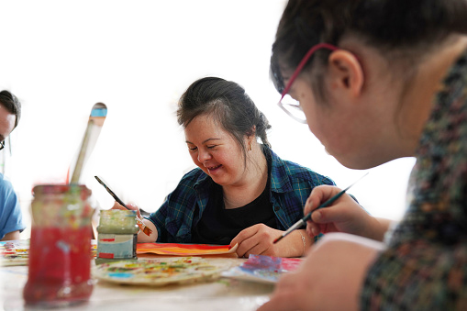

Is it possible to lower the risk of dementia?
It is not possible to prevent dementia with any certainty. Some risk factors, such as age or genetics, cannot be changed. Other risk factors may not be known yet. But you can reduce your risk of future dementia through managing some of your risk factors. The great news is that these changes will also improve your overall health.
There is little information on reducing the risk of dementia specific to people with intellectual disability. However, what is known for the general population is likely to also apply to people with intellectual disability. Some things that are known to increase dementia risk are particularly common in people with intellectual disability, such as low levels of exercise, poorly managed health conditions, and epilepsy. It makes sense to address these – especially if a person has other risk factors that cannot be controlled, such as Down syndrome, or a family history of younger onset dementia.

You can support a person with intellectual disability to aim for good health in older age by supporting them to:
Address health concerns promptly:
- All people with intellectual disability should receive an annual health check. This can detect conditions that would otherwise be missed. Annual health checks can be bulk-billed under Medicare as a ‘Long’ or ‘Prolonged’ annual assessment
- Regular dental checks are important, too
- Pay particular attention to heart health
- Promptly address conditions which cause inflammation
- Be proactive in asking for medications to be reviewed periodically.
Eat a healthy diet:
- The Mediterranean diet has been linked to a lower risk of dementia It is high in vegetables, fruits, whole grains, legumes, and fish.
Get enough exercise:
- The Department of Health website outlines physical activity guidelines for each age group
- If a person is unfit, they should get a check-up before exercising.
Remain engaged:
- An active, stimulating lifestyle lowers the risk of dementia
- Support a person with intellectual disability to be engaged in:
  - social activities – with other people
  - leisure and cognitive activities - to ‘exercise’ the brain
  - physical activities – to keep fit.
For links to resources about good health for people with intellectual disability, go to: https://www.3dn.unsw.edu.au/education-resources .

Track the person’s skills over time when they are healthy
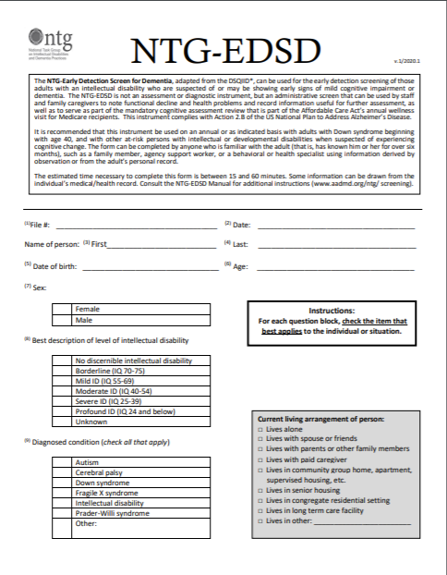
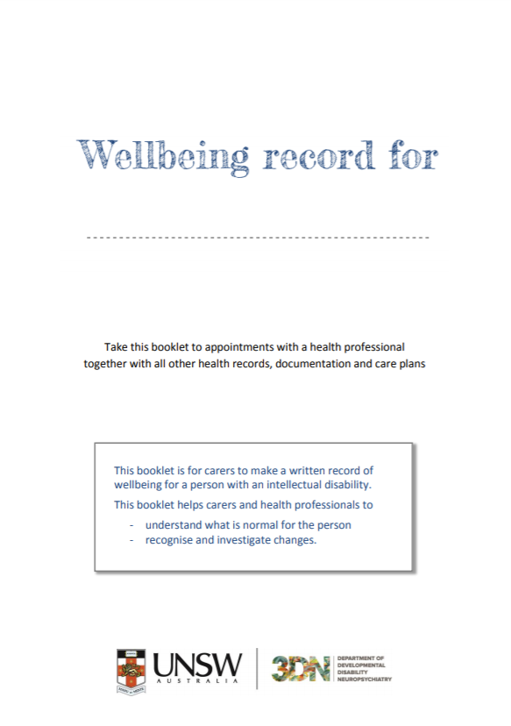
Tracking a person’s skills over time won’t prevent dementia. However, it will document their ‘healthy baseline’ level of skills, making it easier to track changes over time. This simple step may mean an earlier diagnosis if there are changes later.
You can use the Early Detection and Screen for Dementia checklist and the Wellbeing record to record their skills while they are healthy.
If the person has Down syndrome:
- complete the Early Detection and Screen for Dementia at ages 30, 40, and every year after 40
- if possible, arrange a healthy baseline cognitive assessment around age 30. Some people may be eligible for NDIS funding for a private psychologist to complete this assessment. Some private health funds may also give partial rebates.
If the person doesn’t have Down syndrome:
- do the Early Detection and Screen for Dementia at age 40 and repeat it if there are changes in their skills and function.
The Wellbeing Record is recommended for people of any age.
Make sure the forms are stored where they can easily be found later.

Further information and links

For more information about dementia, go to Dementia Australia: https://www.dementia.org.au/
Some books about supporting a person with intellectual disability and dementia are available for loan via the Dementia Australia library: https://www.dementia.org.au/about-us/news-and-stories/news/check-out-these-resources-from-the-dementia-australia-library
Your GP can also provide additional information about dementia.

Information for doctors
You can show this page to the person’s doctor.
Dear Doctor,
This booklet is about dementia in people with intellectual disability.
A dementia screening checklist recommended for people with intellectual disability is available here: https://www.the-ntg.org/ntg-edsd
Our website is here: https://www.3dn.unsw.edu.au/ . It has these resources on dementia and people with intellectual disability for doctors:
- Guidelines for Australian GPs
- e-learning modules
Our website also offers:
- Cardiometabolic resources – this means heart health
- Podcasts about prescribing to people with intellectual disability
We hope you will find these resources helpful.
Yours sincerely,
Department of Developmental Disability Neuropsychiatry, UNSW.

Your notes page

You can use this page to record notes, such as topics to discuss with the person with intellectual disability, or questions to ask the doctor.

……………………………………………………………………………………………………………………………………………………………………………………………………………………………….………………………………………………………………………………………………………………………………………………………………………………………………………………………….…………….…………………..………..…………………………………………………………………………………………………………………………………………………………………………………………………………………………………………………………………………………………….………………………………………………………………………………………………………………………………………………………………………………………………………………………….…………….…………………..………..………………………………………………………………………………………………………………………………………………………………………………………………………………………………………………………………………………………….……………………………………………………………………………………………………………………………………………………………………………………………………………………………………………………………………………………………………………………………

