Participant Information and Consent Form
Photovoice Uncovering the Contribution of People with Intellectual Disability

This sheet has information about research called

The Photovoice Contribution Project

Research means finding out what people think about things and using the information to help other people.

You can ask someone you trust to help you understand this sheet.

Our Team
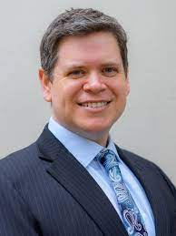 | My name is Dr Sam Arnold. I am a researcher at the University of New South Wales.  I am working with
Aishani Desai

and we are being helped by

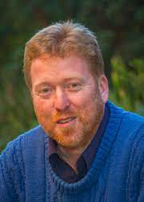 | 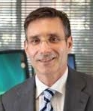 | 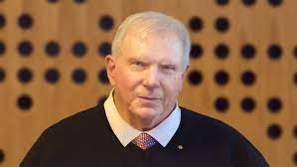 | 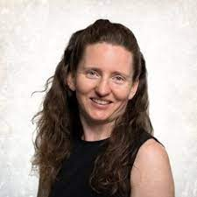
Prof Keith McVilly | Prof Julian Trollor | Adjunct Prof John Walsh AM | Prof Gigi Foster

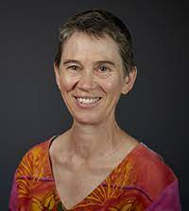
Prof Karen Fisher | Dr Suzy Green

What is it about?

We want to find out about the meaning of contribution.

We want to find out what contribution means to people with intellectual disability.

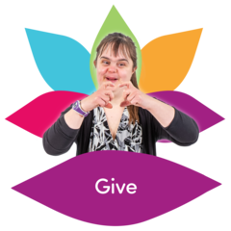 | What is Contribution?  - Helping  - Giving  - Making someone happy  - Doing important things  - Doing important jobs
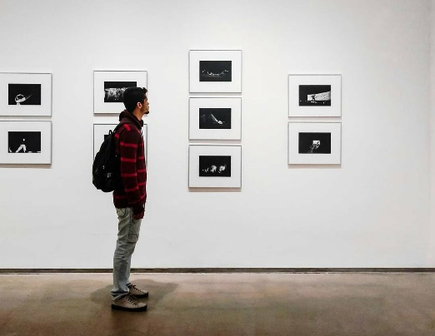 | The Research Project  We have made a gallery.
It has photos and stories about contribution.

We call it the Contribution gallery.
 | We want to know what you think about the galley.
We want to video tape you.
We will ask you questions about the gallery.
We will ask you questions about contribution.

Who can take part in the study?

People who:

- Are 18 years old or over

- Got to see the Contribution gallery.

What does taking part involve?

 | You will be asked questions about the gallery.
 | You will be asked questions about what you think contribution means.
 | We will record what you say.
 |  | The interview should only take 5 minutes.
You can choose which questions to answer.

You can say no if you don’t want to answer a question.
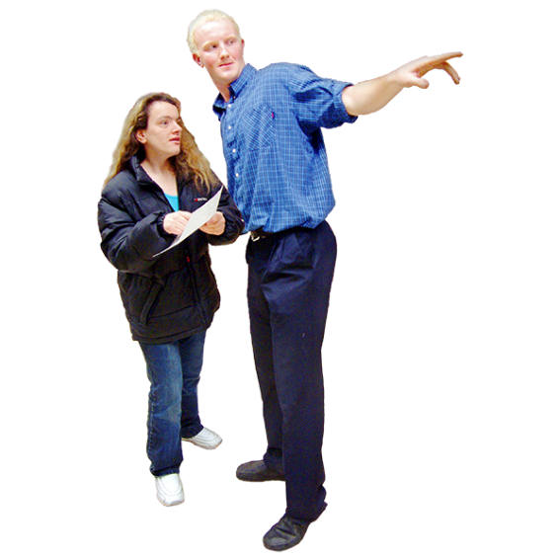 |  | If you want to, someone you trust can help you.
You don’t get anything for doing an interview.

You will be helping our research.

Do I have to take part?

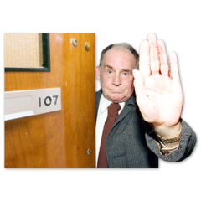 | You only have to take part if you want to.  You can say no. It’s your choice. No one will be angry if you say no.
 | Even if you say yes, you can change your mind later and stop taking part.

What will happen to my information?

We will store your information at UNSW.

We will keep your information private.

We will not tell anybody your name or where you live.

We will write about what we find out.

If you want, we will send you a summary.

Who can I get in touch with about the research?

If you have any questions, get in touch with:

Dr Samuel Arnold
Phone: 02 93850620
Email: Samuel.arnold@unsw.edu.au

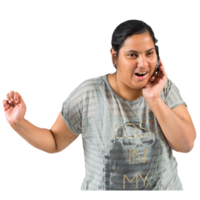 | If you want to complain about the research, you can get in touch with the Human Research Ethics Coordinator. It is their job to listen to you and find out what happened.  Phone: (02) 9385 6222  Email: humanethics@unsw.edu.au  Tell them this number: HC201962
If you feel upset after taking part, you can talk to some who supports you or call:

Beyond Blue
Phone: 1300 224 636
Email: www.beyondblue.org.au

Lifeline Australia
Phone: 13 11 14
Email: https://www.lifeline.org.au/

I want to take part

Photovoice Project Attendee Interview

I am signing this form because I understand about the research and I want to take part.

☐ Tick this box if you have read the information about the study.
Or if someone has explained the study to you.

☐ Tick this box if you understand that you can change your mind later and not be in the study anymore.

☐ Tick this box if you want to bring a family member or support person with you.

☐ Tick this box if you agree we can share what you said with other researchers for their study.

☐ Tick this box if you want us to tell you what we find out from the research.

My signature: ________________________________

Date: ________________________________

My phone number: ________________________________

My address: ________________________________

My email address: ________________________________

I understand that you will only use my contact details for me to take part in the research and to tell me about the findings afterwards.

Witness signature: ________________________________

Date: ________________________________

A witness is someone who saw you sign the form.

I don’t want to take part anymore

Photovoice Project

I am signing this form because I changed my mind. I don’t want to take part anymore and I don’t want you to use what I said.

I understand that the information I gave in the workshop cannot be destroyed given the nature of the recording.

My signature: _____________________

Date: _____________________

Witness signature: _____________________

Date: _____________________

A witness is someone who saw you sign the form.

Send this form to:
Samuel Arnold
Email: Samuel.arnold@unsw.edu.au
Phone: 02 93850620
Postal Address:

