Preventive health care to get better faster or not get worse
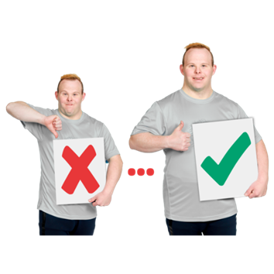 | Preventive health care are things that support people to  - Stay healthy  - Get better quickly when they are sick
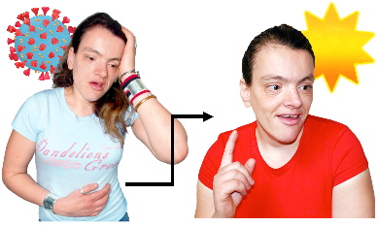 | When you are sick or hurt there are things you can do so you  - get better faster  - do not get worse
Some of these things

- You could do yourself

 | - Your GP could do
 | - Other people or organisations can do
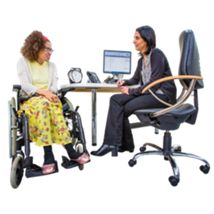 | A GP is the doctor that you see when you  - Are sick  - Need a health check
Things you could do yourself
 | If you are sick or hurt you can protect yourself from getting worse by following the doctors instructions.
You can protect yourself by keeping a healthy weight.

A healthy weight is different for everyone.
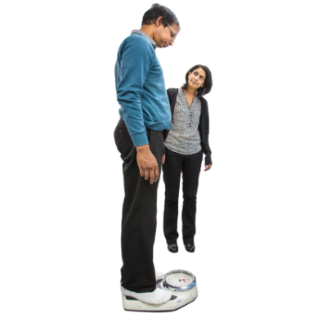 | It is important to talk to your doctor to learn what is healthy for you.
To protect yourself you can

- Eat a balanced diet
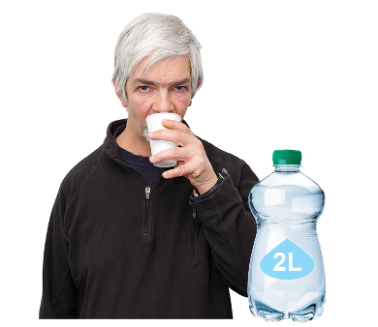 | - Drink 2 litres of water a day  2 litres is about 8 glasses of water a day.
 | - Ask for help if you think you need it
It is OK to ask for help when you

- Feel good

- Do not feel good
 | If you have a mental health problem it is important to let someone know if you think you start to feel worse.
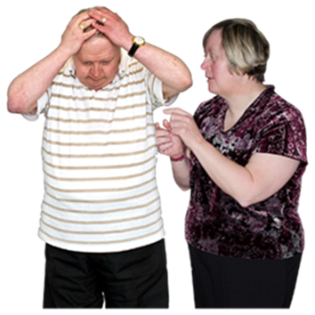 | A mental health problem is when your feelings start to worry you.
Things your GP could do
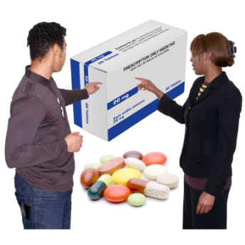 | If you are sick or injured your GP might support you to keep track of your medicines.  Medicine is sometimes called medication or drugs.
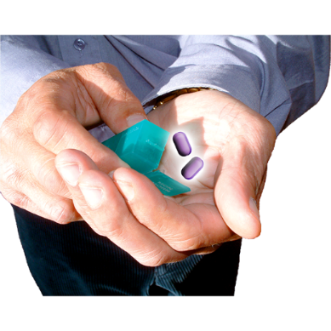 | Medicine can be in  - A tablet  - A pill  - A drink  - An injection
If you are sick or injured your GP might also support you to

- Move your body to help you recover

- Manage your sickness or injury

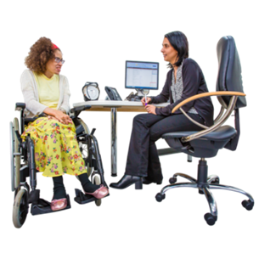 | For example your GP can help you with your mental health.  They can make you a mental health plan.
A mental health plan is a list of things you and other people can do to help you get better.

It is sometimes called a treatment plan.
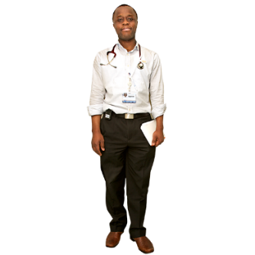 | Your GP can also  Find other doctors who can also help you.
Other things that can support you if you are already sick or injured
You might go to a specialist.

For example a mental health worker like a psychologist or psychiatrist.
A psychologist helps you with your mental health by talking with you.

Psychologists help you find things you can do to feel better.
 | A psychiatrist is a doctor who helps you with your mental health using talking and medicine.

Who wrote this Easy Read

Tahli Hind, Bela Laginha, Dominique Abagi, Julian Trollor, and Janelle Weise.

Where these people work

Department of Developmental Disability Neuropsychiatry UNSW Sydney.

Also known as 3DN.

The information in this part of a series of easy read resourcs about
- Different types of preventive health care
- Who can provide this care

For information on how to support people to use Easy Read go to www.3dn.unsw.edu.au/professionals_toolkit

© Department of Developmental Disability Neuropsychiatry UNSW Sydney 10.08.23 v2

No changes can be made without asking the people who wrote this sheet.

