Types of preventive healthcare to stay healthy
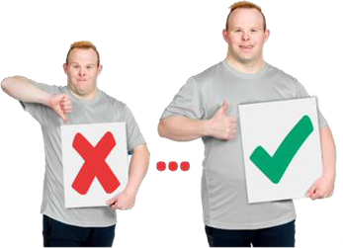 | Preventive health care are things that support people to  - Stay healthy  - Get better quickly when they are sick
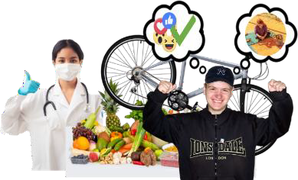 | To stay healthy there are things
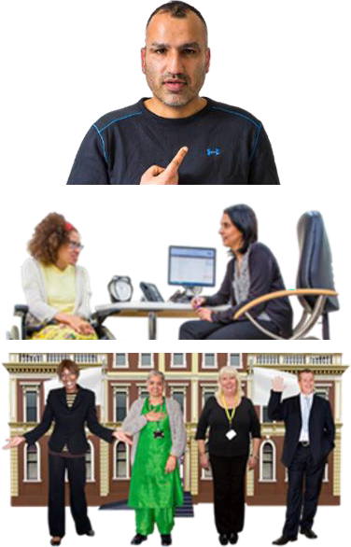 | - You could do yourself  - Your GP could do  - Other people or organisations can do
A GP is the doctor that you see when you
- Are sick
- Need a health check
Things you could do yourself
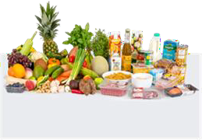 | Food  Eating food that is good for you.
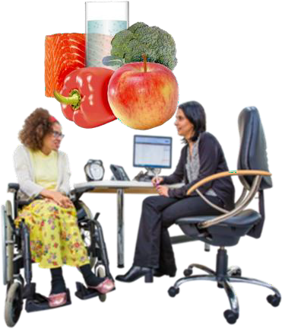 | You might eat a diet your doctor tells you is good for you.
You might also eat different types of food.
For example
- Vegetables
- Fruits
You might also eat

- Proteins like meat and tofu

- Fast food and food from a packet like chips only sometimes
Moving your body

Moving your body can look different for different people.
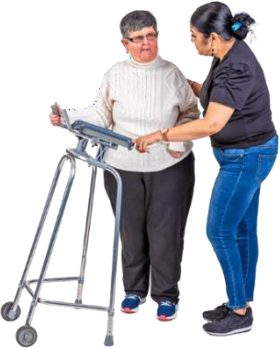 | Some people are able to move their body and exercise.  Some people need support to do these things.
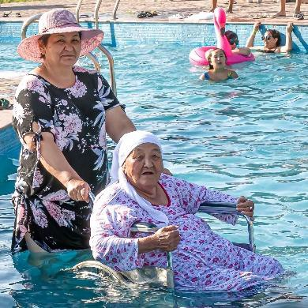 | To move your body you might  - Get support to swim
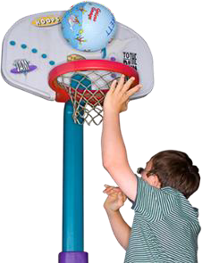 | - Play sport
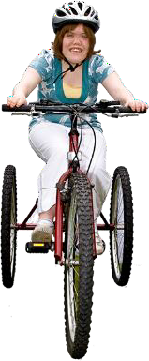 | To move your body you might also  - Ride a bike that is made to suit you
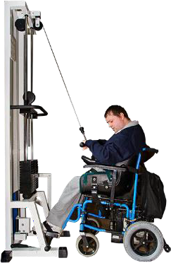 | - Go to the gym
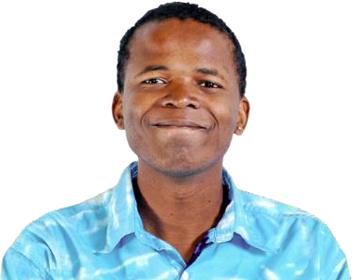 | Mental wellbeing  Mental wellbeing is when you
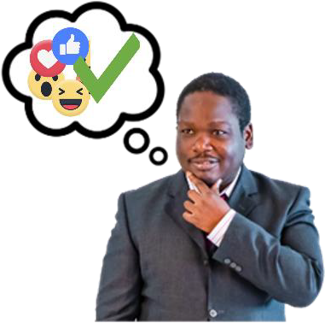 | - Feel OK about having different kinds of feelings  - Can cope with stress
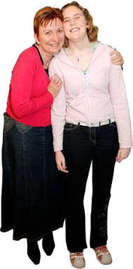 | Mental wellbeing is also when you  - Have people who support you
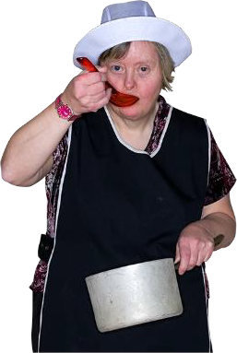 | - Can do everyday things
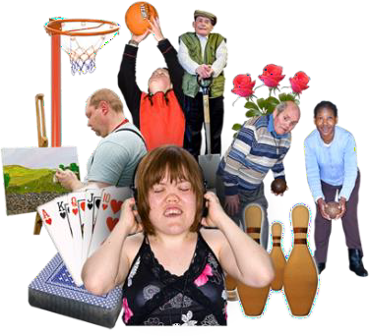 | - Can do activities you want to do
To look after your mental wellbeing you might

- Do things you enjoy
- Support your community

For example helping in beach clean ups.
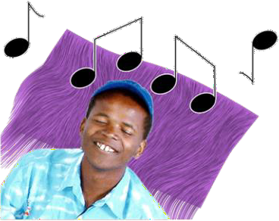 | - Look after yourself  For example listening to music.
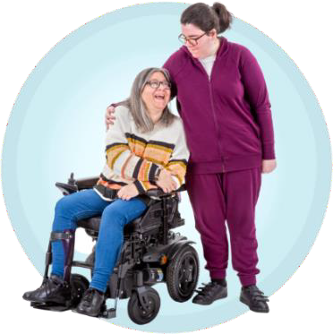 | Social wellbeing  Social wellbeing is when you have and can keep good relationships with others.
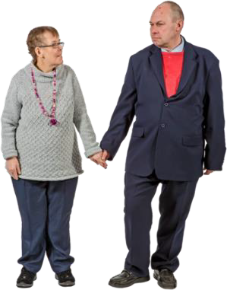 | A relationship is a way that 2 or more people are joined by something in their lives.  People can be joined by something they share or have in common.
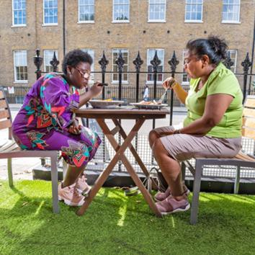 | For example you might have a relationship with  - Your friends
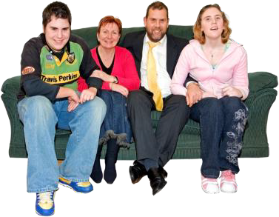 | - Your family
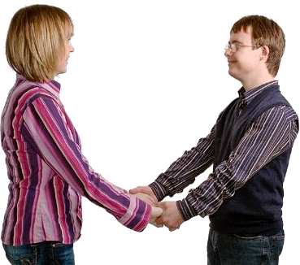 | - Your partner
- People you work with

Relationships can look different for everyone.
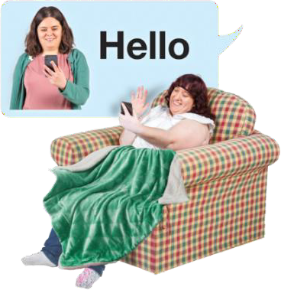 | To look after your social wellbeing you might  - Call or visit family and friends
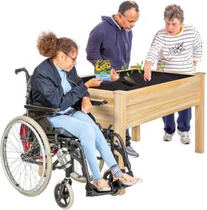 | - Join a group in your community
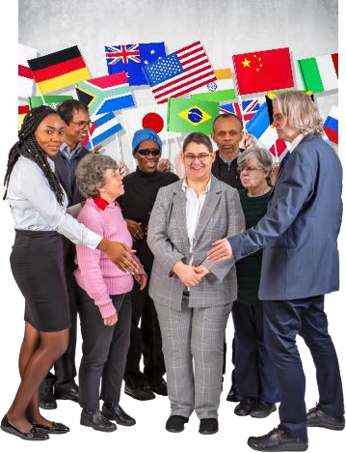 | Cultural wellbeing  Many people have strong connections to their  - Culture  - Community  - Land  - Spirituality
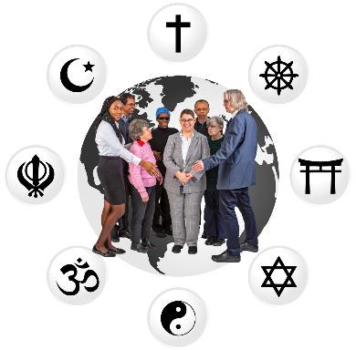 | Cultural wellbeing is when your connections to these things are strong.
 | Land describes a place you might feel a connection to because it is where your family come from.
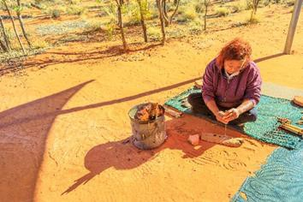 | Spirituality is a way of understanding life and connecting to others.  Spirituality can provide a sense of meaning.
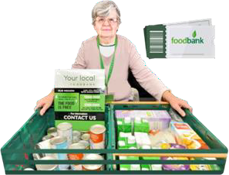 | A sense of meaning gives us a feeling that we are part of something and life is useful and valuable.
Alcohol, tobacco, illegal drugs
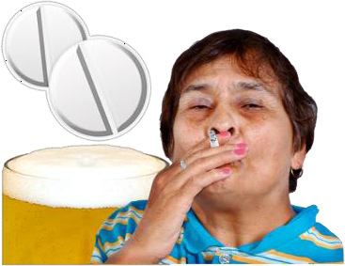 | Some people  - Drink alcohol  - Use tobacco  - Use illegal drugs
 | To stay healthy you might have less or none of these things.
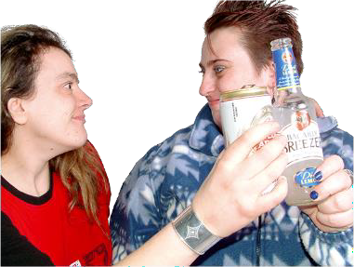 | For example if you drink lots of alcohol you might try to drink one or two drinks a week instead.
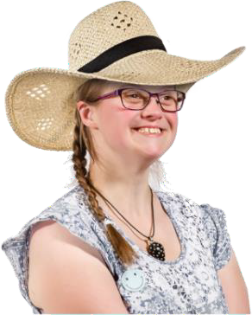 | Sun Safety  It is important to get sunlight to stay healthy.
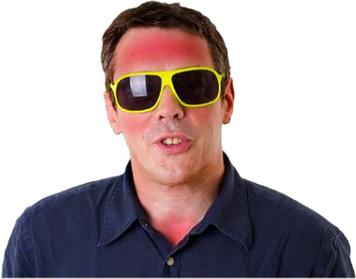 | Too much sunlight can hurt your body.  Sun safety is when you protect yourself from getting hurt from the sun.
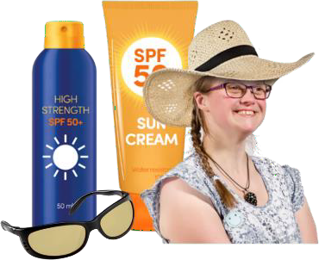 | To be sun safe you might  - Wear a hat  - Wear sunscreen that is SPF30+ or more  - Wear sunglasses
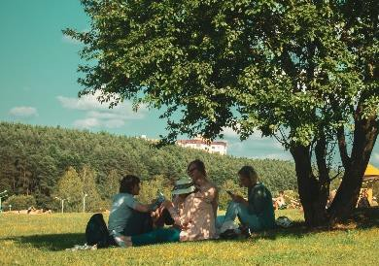 | - Put on clothes that cover your skin  - Try sit in the shade or under shelter
Learning about how to be healthy
To learn more about how to stay healthy you might ask your GP for information.

You might also look for information online.
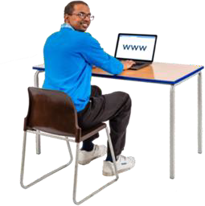 | For example CID has some Easy Read health fact sheets www.cid.org.au/our-health-fact-sheets
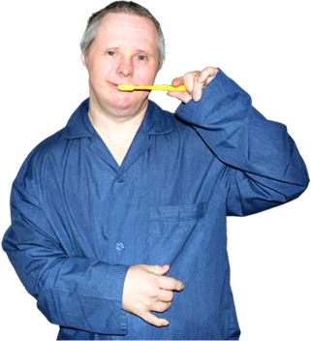 | Mouth  To look after the health of your mouth you might  - Brush your teeth 2 times a day  - Floss your teeth 2 times a day
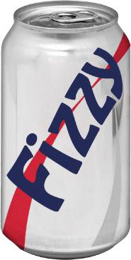 | - Drink less or no soft drinks
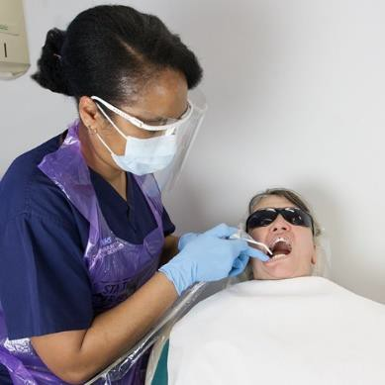 | To look after the health of your mouth you might Also go to the dentist 2 times a year.  A dentist is a doctor who supports you in keeping your teeth and mouth healthy.
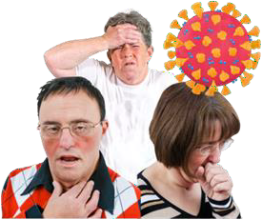 | Staying healthy from infectious diseases Infectious diseases are a type of sickness.  For example COVID-19 is an infectious disease.
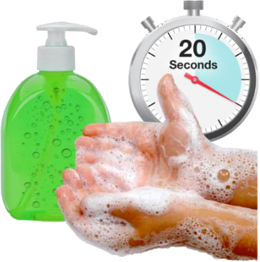 | To stay healthy from an infectious disease you might  - Wash your hands often
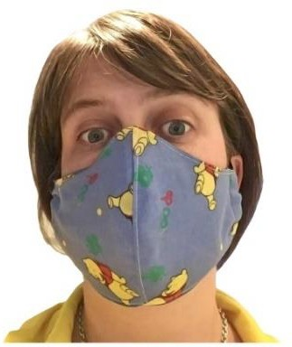 | - Wear a face mask when you are inside with lots of people
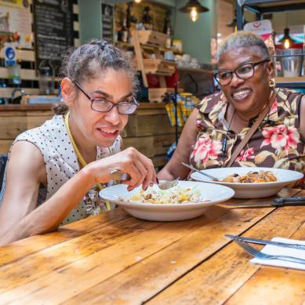 | To stay healthy from an infectious disease you might also  - Not share your food or drinks with other people
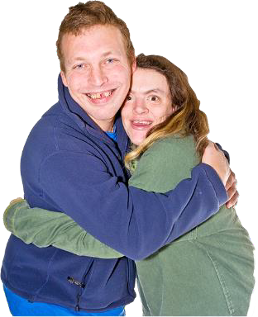 | - Look after your sexual health  Sexual health is about keeping safe before, during and after sex.
To find out more about sex and sexual health you can go to
- NSW family planning Easy Read Factsheets www.fpnsw.org.au/ factsheets/individuals/disability/all-about-sex
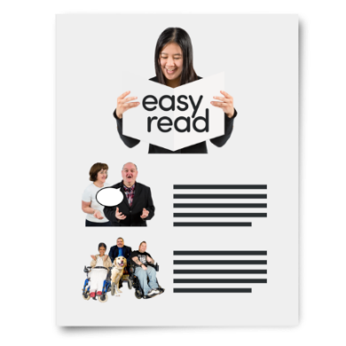 | - Easy read leaflets from the UK www.icash.nhs.uk/contraception-sexual-health/easy-read-leaflets
Things my GP could do
Regular check ups at the GP can help you to stay healthy.

Your GP can do certain health checks.
 | To find out more go to www.cid.org.au/resource/yearly-health-check-fact-sheet
 | Your GP might support you to stay healthy by doing some of te things listed below.
Talk to you

A GP might ask you questions about your life to find out more about your
- Mental wellbeing
- Social wellbeing
- Cultural wellbeing
- Physical wellbeing
- Sexual health
- History
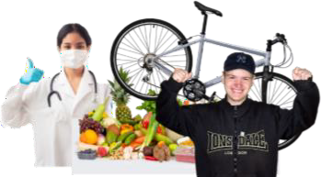 | Physical wellbeing is when your body functions at the right age for you.
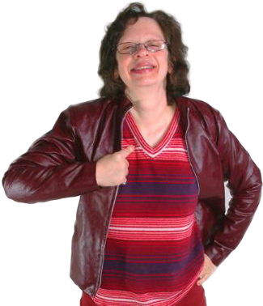 | Your history are things that have happened in the past.  Your GP might ask about your medical history or family history.
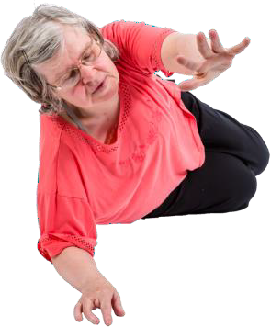 | Your medical history is about any big injuries or sicknesses you have had in the past.  For example if you had a fall.
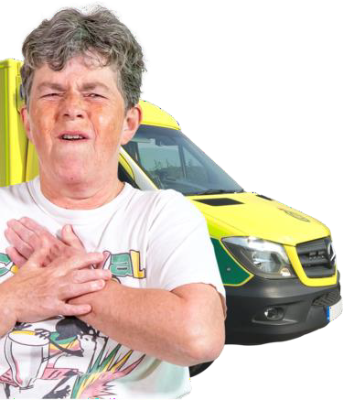 | Family history is about any big sicknesses that your family might have had.  For example if one of your parents has had a heart attack before.
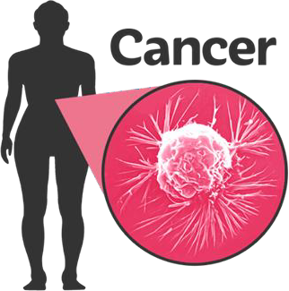 | It might also be a sickness someone in your family has right now.  For example 1 of your grandparents has cancer.
 | Knowing your history helps your GP to support you to stay healthy.
 | Your GP might also give you information or ideas about how you can stay healthy.
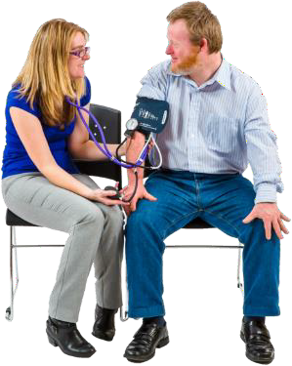 | Blood pressure  Blood pressure is how strong your heart can move blood around your body.
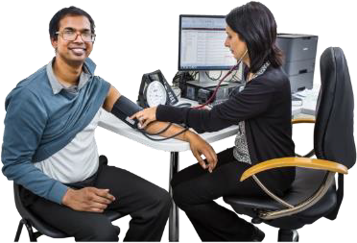 | Blood pressure can tell a doctor important information about your  - Heart health  - How blood moves in your body
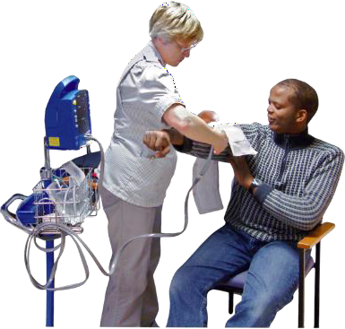 | To check your blood pressure your GP will wrap your arm above your elbow with a cuff.
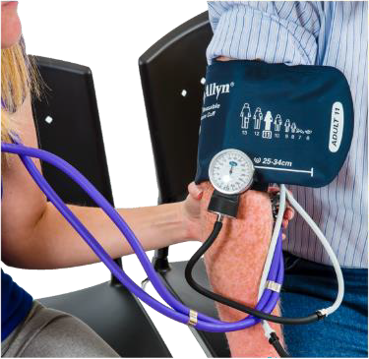 | This cuff will  - Get tight and squeeze your arm  - Then slowly loosen
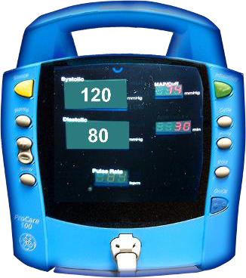 | Your GP will be able to find out your blood pressure from a machine or dial connected to the cuff.  Blood tests
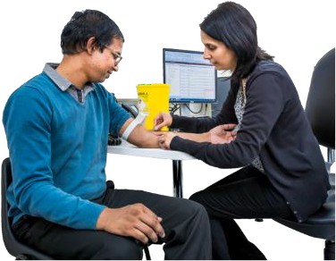 | Your blood can tell your doctors a lot of information about your health.
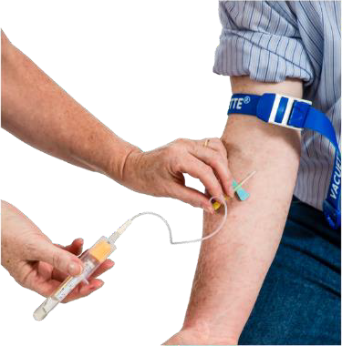 | To check your blood your GP will ask you to do a test.  You can ask your GP for a test too.
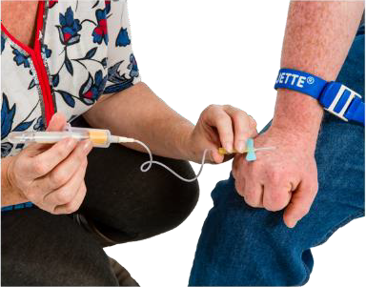 | To do a blood test a worker who knows a lot about taking blood
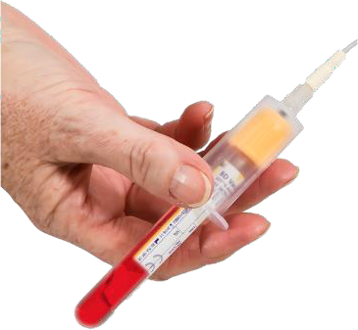 | - Takes some of your blood with a needle  - Sends your blood to a place where they can look at your blood closely
 | Your blood test results are sent to your GP.
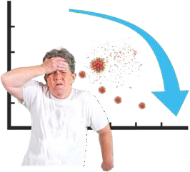 | Immunisation  Immunisation is the way the body learns to fight a disease.  Immunisation is what happens when a person gets better from an infection or gets a vaccine.
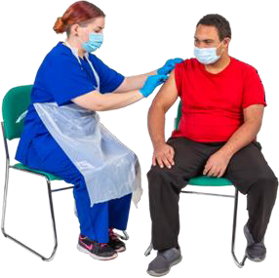 | A vaccine is a medicine that helps people to get immunisation.
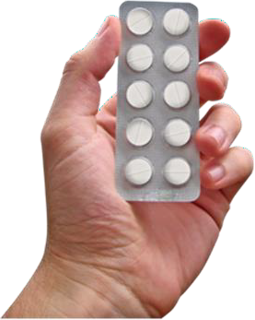 | Medicine is sometimes called medication or drugs.
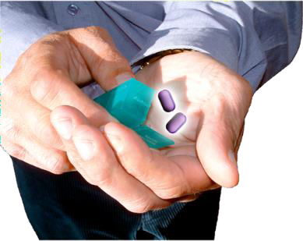 | Medicine can be in  - A tablet  - A pill  - A drink  - An injection
 | Vaccines are an injection that are mostly given in your arm.
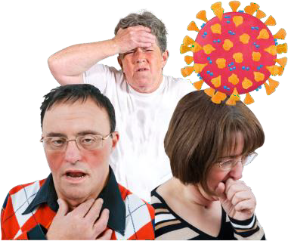 | Vaccines usually protect you from 1 or more types of disease.
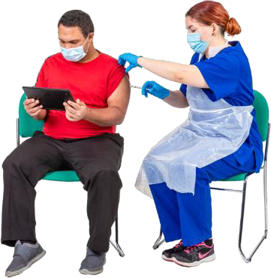 | You might get vaccinated by your GP or another health worker.  For example your GP might have given you a COVID-19 vaccine.
Other things that can support you to stay healthy
 | Sometimes the government or an organisation try to do things to make it easier for people to stay healthy.
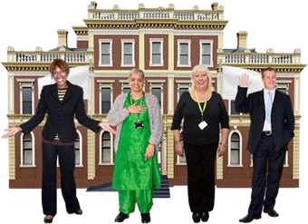 | The government is a group of people.  They protect and support people in a certain area.
For example the government or organisation might make things to help people stay healthy.

For example posters with information on how to wash your hands right.
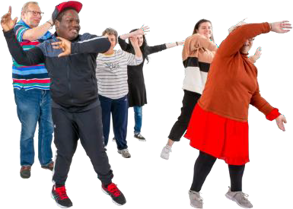 | For example the organisation you work at might exercise before lunch together.
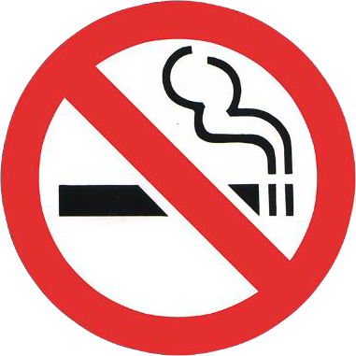 | Another example is making it harder to use tobacco by not letting people smoke in certain areas.

Who wrote this Easy Read

Tahli Hind, Dominique Abagi, Bela Laginha, Julian Trollor, and Janelle Weise.
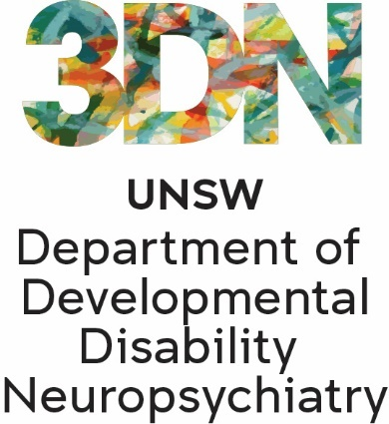 | Where these people work  Department of Developmental Disability Neuropsychiatry UNSW Sydney.  Also known as 3DN.  This information sheet is part of a series of easy read resources about
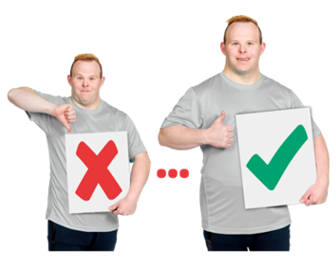 | - Different types of preventive health care  - Who can provide this care  For information on how to support people to use Easy Read go to www.3dn.unsw.edu.au/professionals_toolkit
© Department of Developmental Disability Neuropsychiatry UNSW Sydney 11.08.23 V2

No changes can be made without asking the people who wrote this sheet.

