Preventive health checks
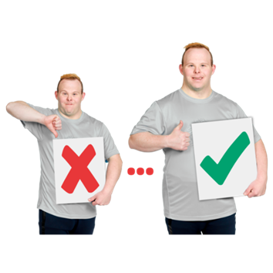 | Preventive health care are things that support people to  - Stay healthy  - Get better quickly when they are sick
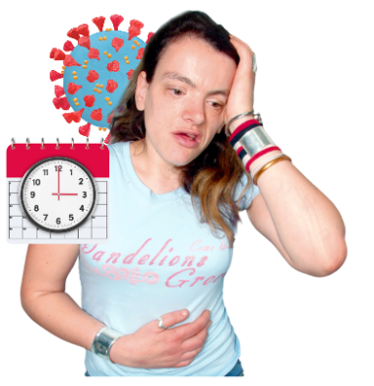 | Getting a health check can help you find out if you are sick so you can get support.  Health checks are tests that can help you find out if you are sick.
 | Some health checks
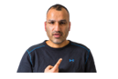 | - You could do yourself
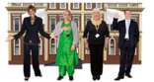 | - Other people or organisations can do
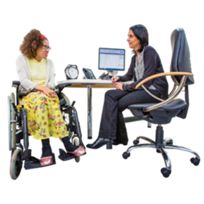 | A GP is the doctor that you see when you  - Are sick  - Need a health check
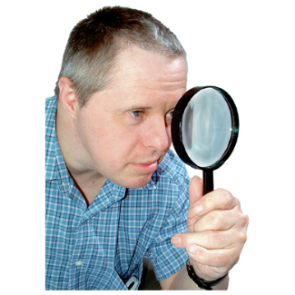 | There are different types of tests for different types of sicknesses.
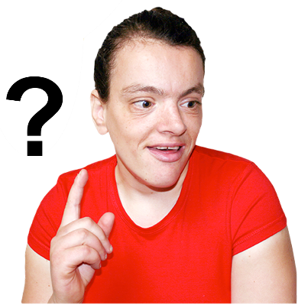 | These find out if  - Anything has changed in your body  - Your body is doing things it does not normally do
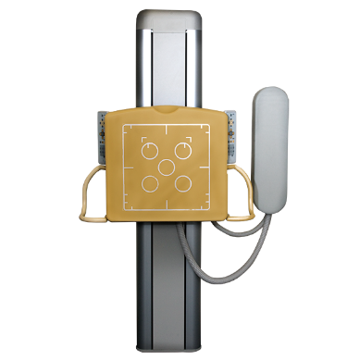 | Some tests are done with machines.
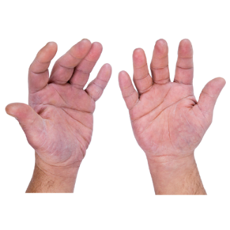 | Some checks are done with hands.
For tests done with hands you can ask your GP to
- Do this type of check

- Show you how to do it yourself
Things you could do yourself
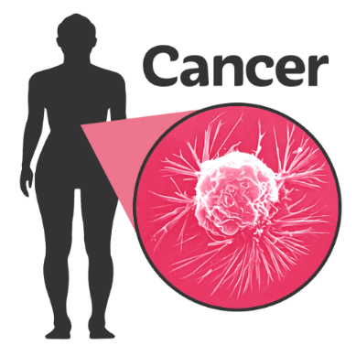 | Cancer screening  Cancer screening are tests to check if a person has cancer.
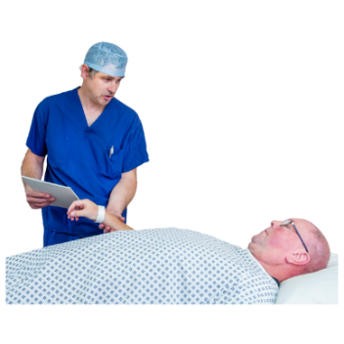 | There are different types of tests for different types of cancer.  It is done to find out if a person has cancer.
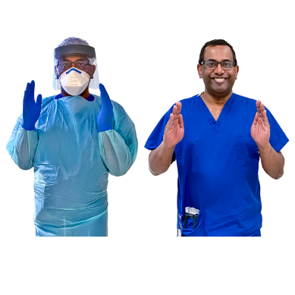 | Some examples of common checks are breasts or testicles.  Breasts are sometimes called boobs.  Testicles are sometimes called balls.
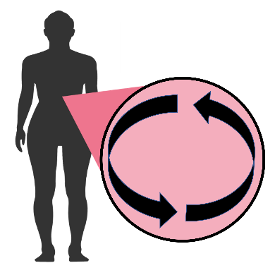 | These checks might look for changes in  - Shape  - Colour  - Size  - Feeling
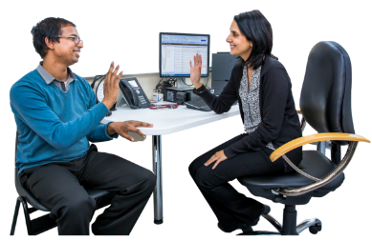 | You or your GP can do these checks.  You can ask your GP to show you how to do a check.  If you notice anything change you should see your GP
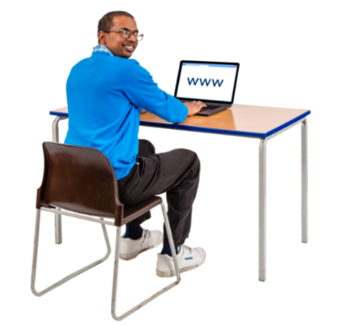 | To find out more about these checks go to CIDs factsheets about types of health checks www.cid.org.au/resource/types-of-health-checks-fact-sheet/
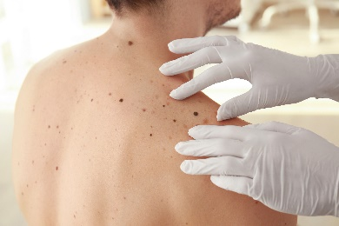 | Another common type of check is a skin check.  A mole is a dark mark on your skin.  Moles are normally round in shape.
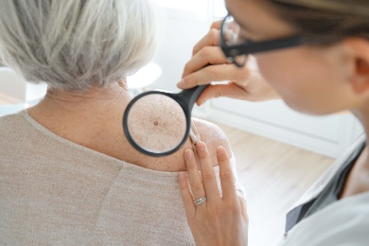 | Many people have moles.  Some moles change as we get older.  Some changes are OK.
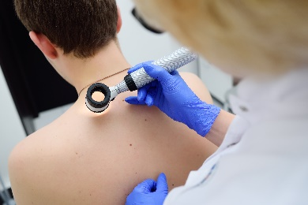 | Some changes might mean you have cancer.  This is why it is important to do skin checks.
A skin check looks for changes in your moles
- Shape
- Colour
- Size
- Feeling
 | For example it feels rough or dry when you touch it.
To find out more about mole checks go to the Cancer Council
www.cancer.org.au/cancer-information/causes-and-prevention/sun-safety/check-for-signs-of-skin-cancer
Things your GP could do
Cancer screening

Some cancer screening tests can be done by your GP.
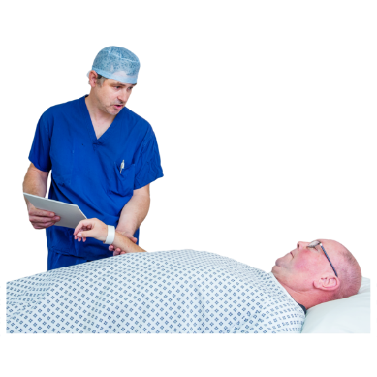 | Your GP might also send you to get a test somewhere else to do a cancer screen.
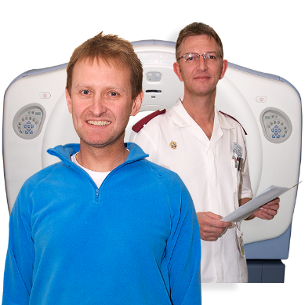 | Some examples of common cancer screens are a  - Cervical screening test  - Mammogram  - Prostate screening test
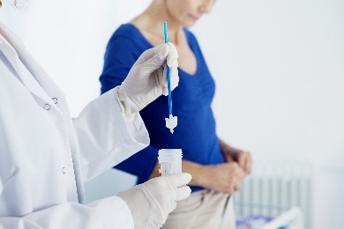 | A cervical screening test is when a doctor like your GP checks your cervix for a  - Type of cancer called cervical cancer  - A sexually transmitted disease
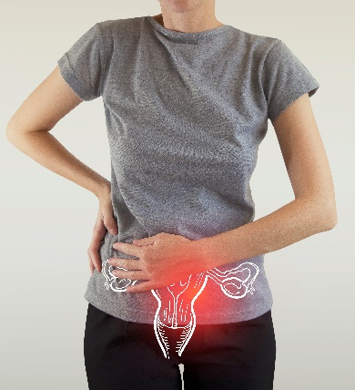 | Your cervix is inside your body.  It is above your vagina.
 | To find out more go to www.fpnsw.org.au/justchecking/easyenglish
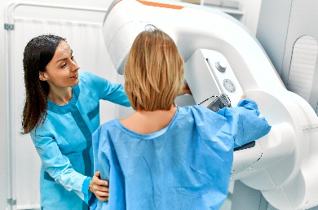 | Your GP might send you somewhere to get a mammogram.  A mammogram is a machine that checks your breasts for cancer.
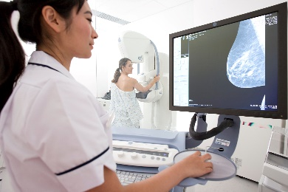 | This test is mostly done by someone who knows a lot about different types of scans.  A scan takes pictures of the inside of your body.
 | To find out more go to www.fpnsw.org.au/justchecking/easyenglish
There are different types of prostate screening tests.

For example a

- Blood test

- Test called a digital rectal examination
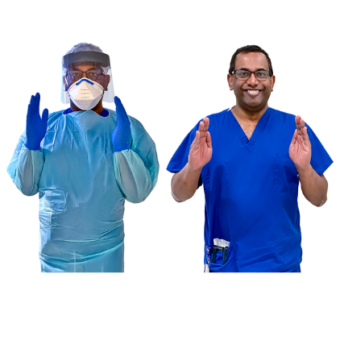 | A digital rectal examination is done by your doctor.  The test is mostly done by a specialist doctor called a urologist.
 | Specialists are people who know a lot about a certain area.
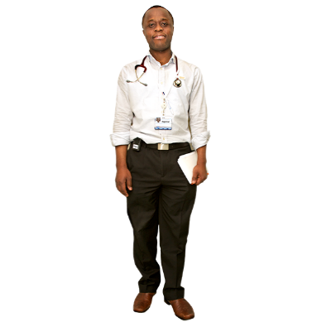 | A urologist is a doctor who knows a lot about the body parts that make, hold and get rid of urine from the body.  Urine is sometimes called wee.
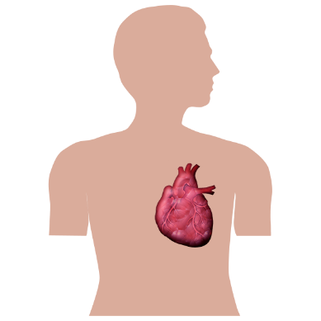 | Tests for your heart health  There are some tests that let your GP know that you might have a heart health problem.
For example
- Blood tests

- Blood pressure

- Scans
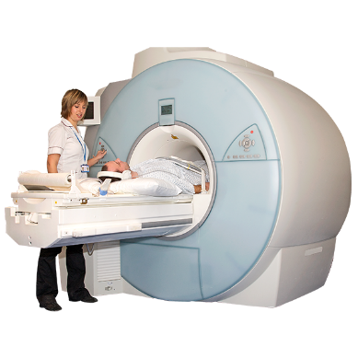 | A scan takes pictures of the inside of your body.  For example CT scans takes 3D pictures of a part of your body.
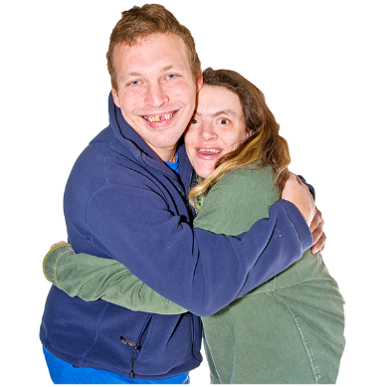 | Tests for your sexual health  Sexual health is about staying safe before, during and after sex.
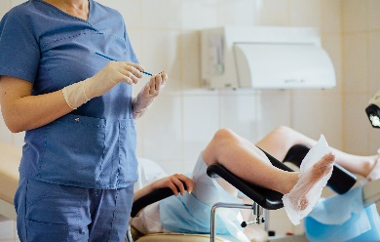 | The tests for sexual health look for sexually transmitted diseases.
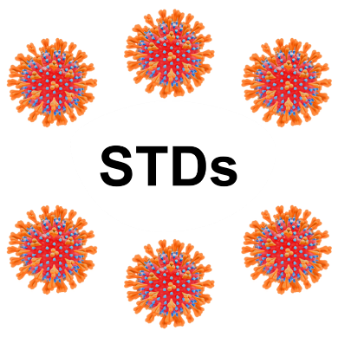 | Sexually transmitted diseases are sometimes called STDs.  There are different types of STDs.  For example HIV and Chlamydia.
To find out more about sex, STDs and sexual health go to
- NSW Family planning Easy Read Factsheets

- www.fpnsw.org.au/factsheets/individuals/disability/all-about-sex
- Easy Read leaflets from the UK
www.icash.nhs.uk/contraception-sexual-health/easy-read-leaflets
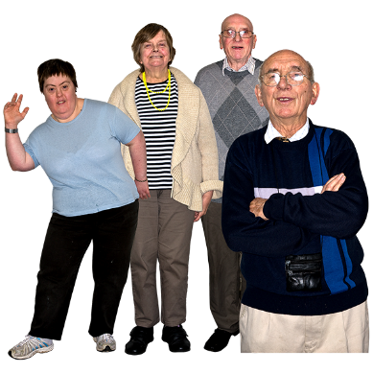 | Tests for your bones  As people get older their bones can become weak.  Weak bones can be hurt more easily.
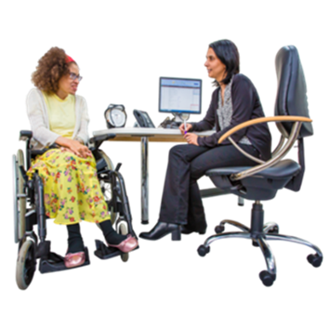 | Your GP might want to find out if you have weak bones so they can help you avoid bad injuries.
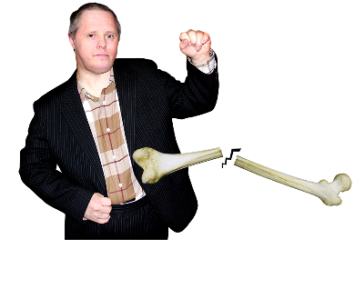 | To find out if you have weak bones your GP might ask you to do a heel ultrasound.
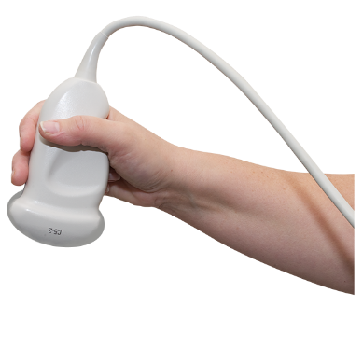 | A heel ultrasound is a machine that looks at how strong your bones are.
Other health checks
You might go to a specialist.

Specialists are people who know a lot about a certain area.

For example an audiologist or optometrist.
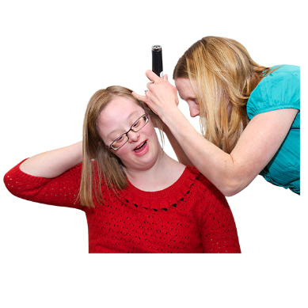 | An audiologist looks after the health of your hearing and ears.  An audiologist might give you hearing aids.
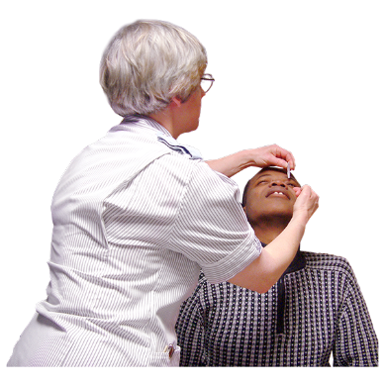 | An optometrist looks after the health of your eyes.  An optometrist might give you glasses.
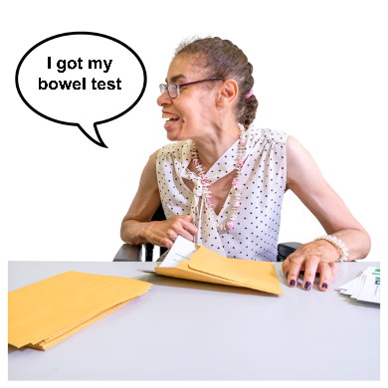 | You might get a cancer screen sent to your home in the mail.  For example bowel screening tests are sent to Australians after they turn 50.
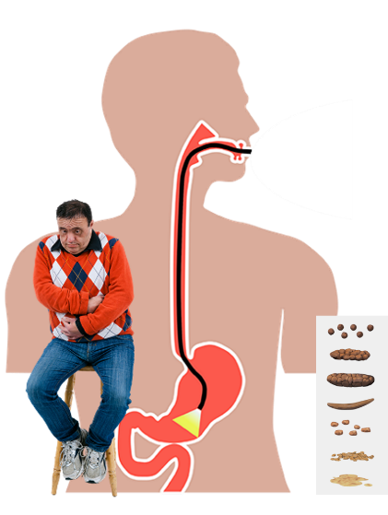 | Bowels are inside your tummy.  They are sometimes called your guts.  Your bowel makes your poo.  Bowel screening tests your poo to find out if you have bowel cancer.
 | To find out more go to www.fpnsw.org.au/justchecking/easyenglish

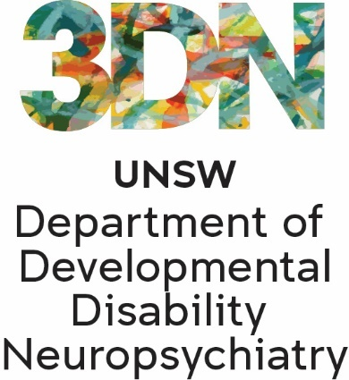 | Who wrote this Easy Read  Tahli Hind, Bela Laginha, Dominique Abagi, Julian Trollor, and Janelle Weise.  Where these people work  Department of Developmental Disability Neuropsychiatry UNSW Sydney.  Also known as 3DN.
The information in this part of a series of easy read resourcs about
- Different types of preventive health care
- Who can provide this care

For information on how to support people to use Easy Read go to www.3dn.unsw.edu.au/professionals_toolkit

© Department of Developmental Disability Neuropsychiatry UNSW Sydney 10.08.23 v3

No changes can be made without asking the people who wrote this sheet.

