Tre

What is preventive health care?

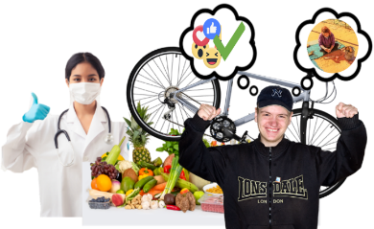 | Many things can  - Support you to be healthy
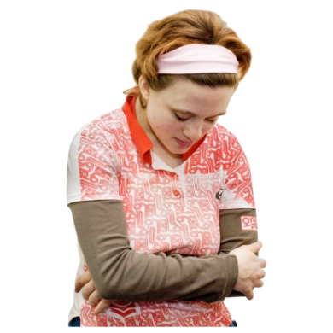 | - Make it harder for you to be healthy
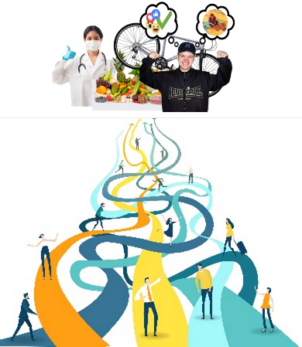 | For example it can be harder for you to be healthy if you do not have a healthy weight.
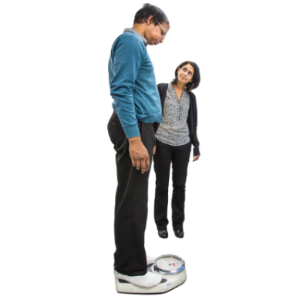 | A healthy weight is different for everyone.
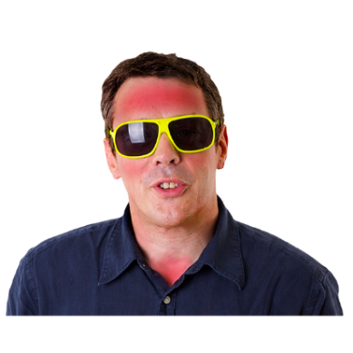 | It can also be harder for you to be healthy if you do not protect yourself when you are in the sun.
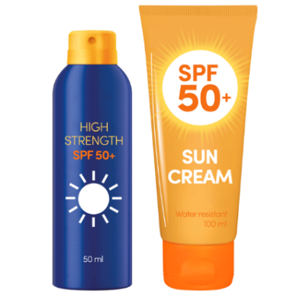 | You might protect yourself from the sun by wearing  - SPF30+ or more sunscreen
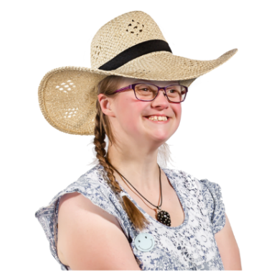 | - A hat
 | - Clothes that cover your body
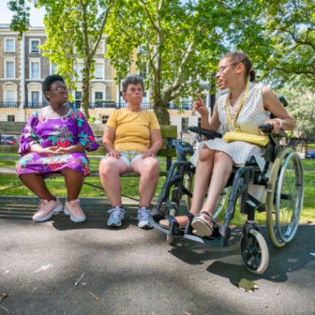 | You can also protect yourself by sitting in the shade.
It can also be harder for you to be healthy if you

- Drink lots of alcohol

- Use illegal drugs
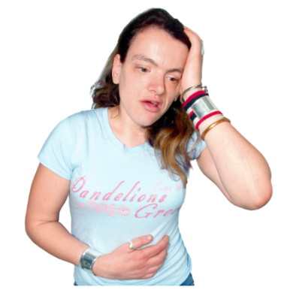 | Illegal drugs are substances that  - Can hurt you
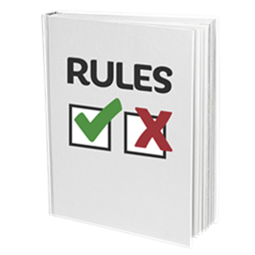 | - The law says you should not have  Laws are a set of rules that everyone must follow.
You can be supported to be healthy by

- Eating a balanced diet
 | - Moving your body
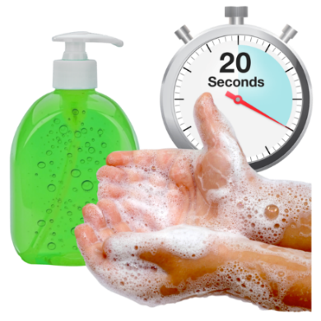 | - Doing things that protect you from infection  For example washing your hands.
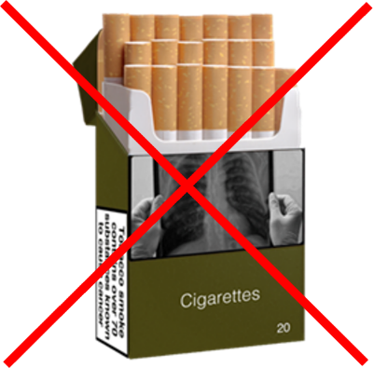 | You can also be supported to be healthy by not using tobacco.  Tobacco is a chemical that is in  - Cigarettes  - Cigars  - Chewing tobacco  - E-cigarettes
 | Tobacco use is when people use these things.
 | Preventive health care is something that can support people to be healthy
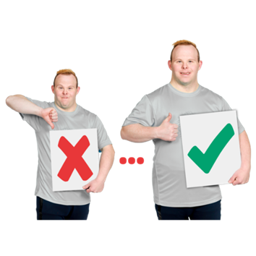 | Preventive health care are things that support people to  - Stay healthy  - Get better quickly when they are sick
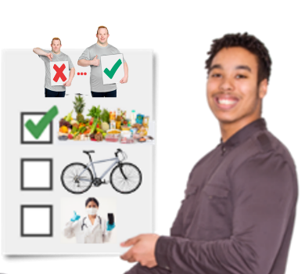 | There are different types of preventive health care.
Some types of preventive health care support you to

- Stay healthy
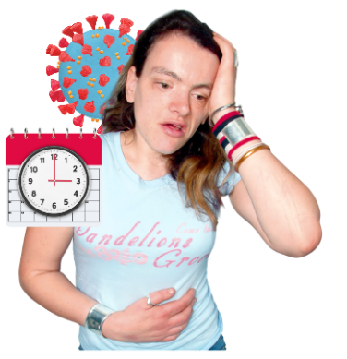 | - Get health checks
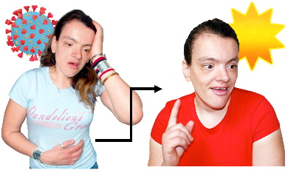 | - Get better faster or not get worse if you are already sick or hurt
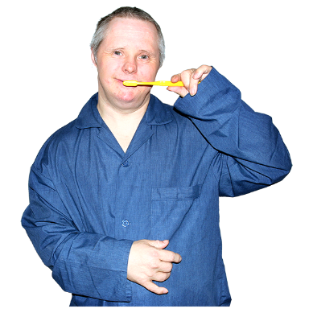 | You might use preventive health care to stay healthy by brushing your teeth twice a day.
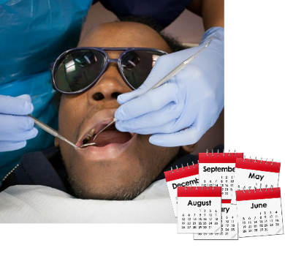 | You might get a preventive health check at the dentist every 6 months.
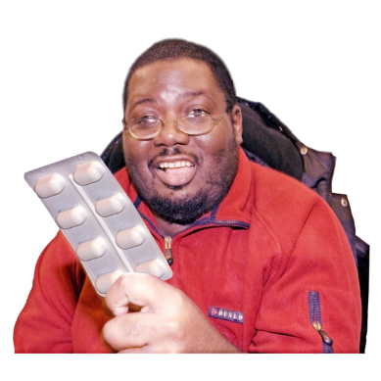 | The dentist might give you medicine if you have an infection.  This is so you can get better faster and not get worse.
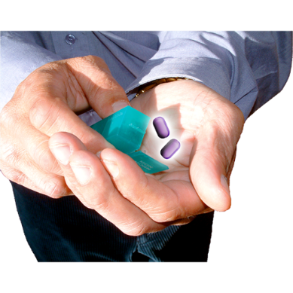 | Medicine is sometimes called medication or drugs.  Medicine can be in  - A tablet  - A pill  - A drink  - An injection
 | Different people can provide these types of preventive health care.
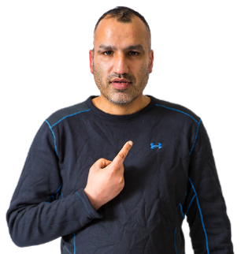 | This could be provided by  - Yourself
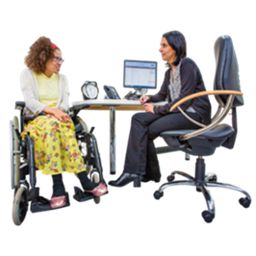 | - Your GP
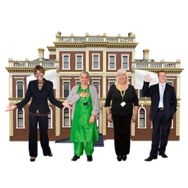 | - Other people or organisations
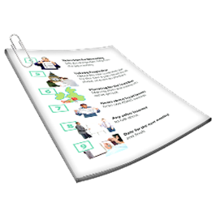 | You might want more information about  - Different types of preventive health care  - Who can provide this care to you
 | If you want more information please see Easy Read documents
 | - Preventive health care to stay healthy
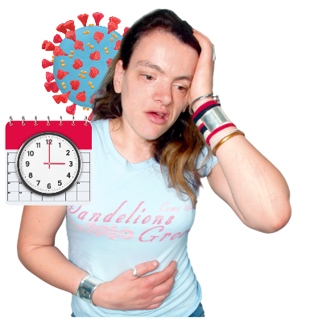 | - Preventive health checks
 | - Preventive health care to get better faster or not get worse

Who wrote this Easy Read

Tahli Hind, Dominique Abagi, Bela Laginha, Julian Trollor, and Janelle Weise.
Where these people work

Department of Developmental Disability Neuropsychiatry UNSW Sydney.

Also known as 3DN.
This information sheet is part of a series of easy read resources about

- Different types of preventive health care

- Who can provide this care
For information on how to support people to use Easy Read go to www.3dn.unsw.edu.au/professionals_toolkit

© Department of Developmental Disability Neuropsychiatry UNSW Sydney 11.08.23 v2

No changes can be made without asking the people who wrote this sheet.

